**Problem 1:**

Given the graph G = (V,E), solve the Towers of Hanoi game where:

* V = (Start, Aux1, Aux2, Aux3, Aux4, Dest)
* E = {(Start, Aux1), (Aux1, Aux2), (Aux2, Aux3), (Aux3, Aux4), (Aux4, Aux1), (Aux1, Dest)}

We must design and provide an algorithm, as well as determining the time and space complexities of given algorithm that moves an n amount of disks from Start to Dest. The algorithm should print out each move of every disk, and we must show the output for disks n = 1, 2, 3,…,10. If the output becomes too large, then only the first and last 100 moves (200 total) need to be recorded.

The algorithm takes in no input. The number of disks impacts the Towers of Hanoi game’s output by dramatically increasing the number of moves (2^n – 1) required for each additional disk.

We assume that the Towers of Hanoi game program works just as the real version. This means that a disk can only be moved from a peg if the disk is at the very top of the peg’s stack. A disk may only be placed on to another disk if it is smaller than the new peg’s stack. A larger disk cannot be placed on a smaller disk.

There are several data structures involved in this program that represent each component of the actual game. The graph maps out the connections between each peg, which are represented by nodes in the graph. The disks of the game are represented by numbers, with 1 being the smallest. The disks are stored in the nodes’ stacks.

The algorithm itself comes with many assumptions. It assumes that the disks were placed on Start in a valid (ascending) order, and that no other peg contains disks. The disks are always assumed to be in a valid order, with no large disks being placed upon a smaller disk. The algorithm moves the entire stack of disks from Start to Aux4, and then from Aux4 to Dest, using a cycle to do so. The cycle includes the four auxiliary nodes with the Start node connected to Aux1 and the Dest (destination) node connected to Aux4. While there are still disks on Start, we will move the top disk from Start to Aux3. We then move the stack onto Aux4 across the cycle, and move the disk from Aux3 onto Aux4. From Aux4, we move the disks onto Aux1 before finally moving them onto the Dest node.

The algorithm that moves the stack calls itself three times for n-1. The time complexity is therefore O(3^n)-1 or just O(3^n). The space complexity is only O(n) because only one call is added to the runtime stack at a time.

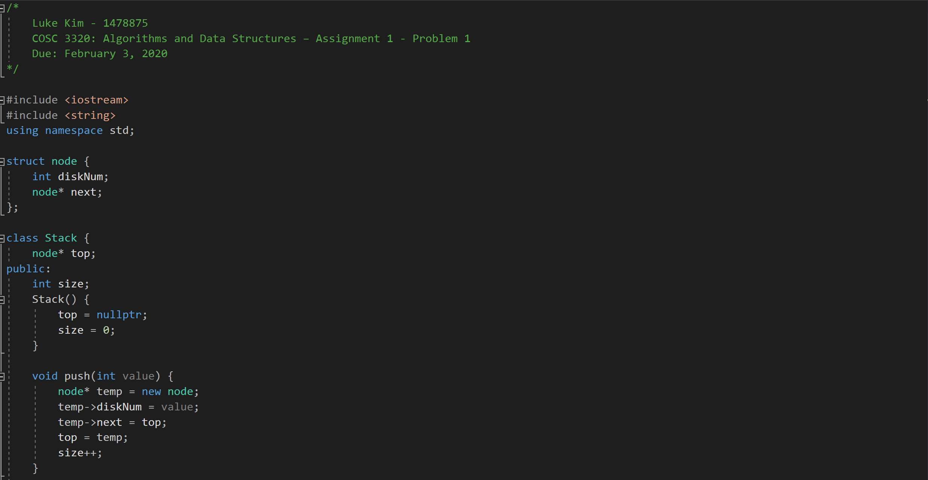

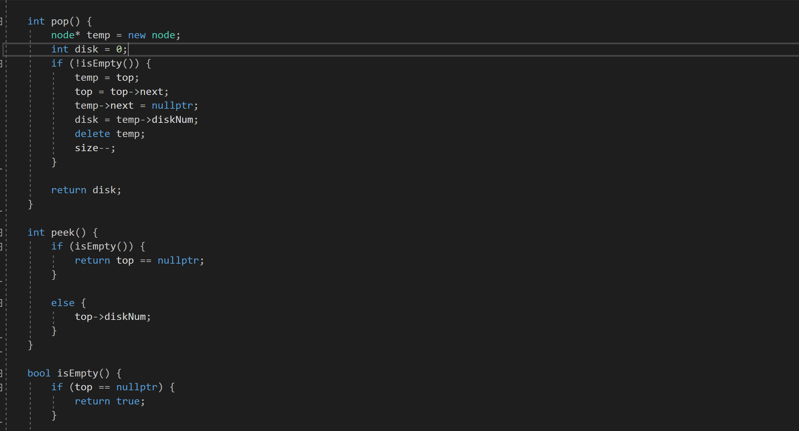

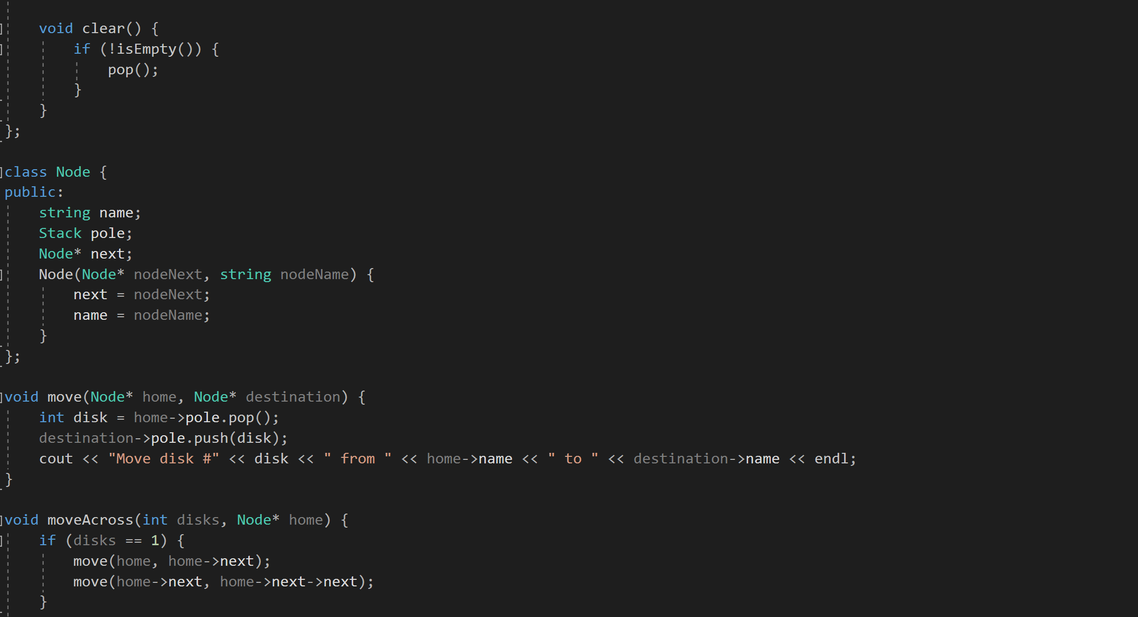

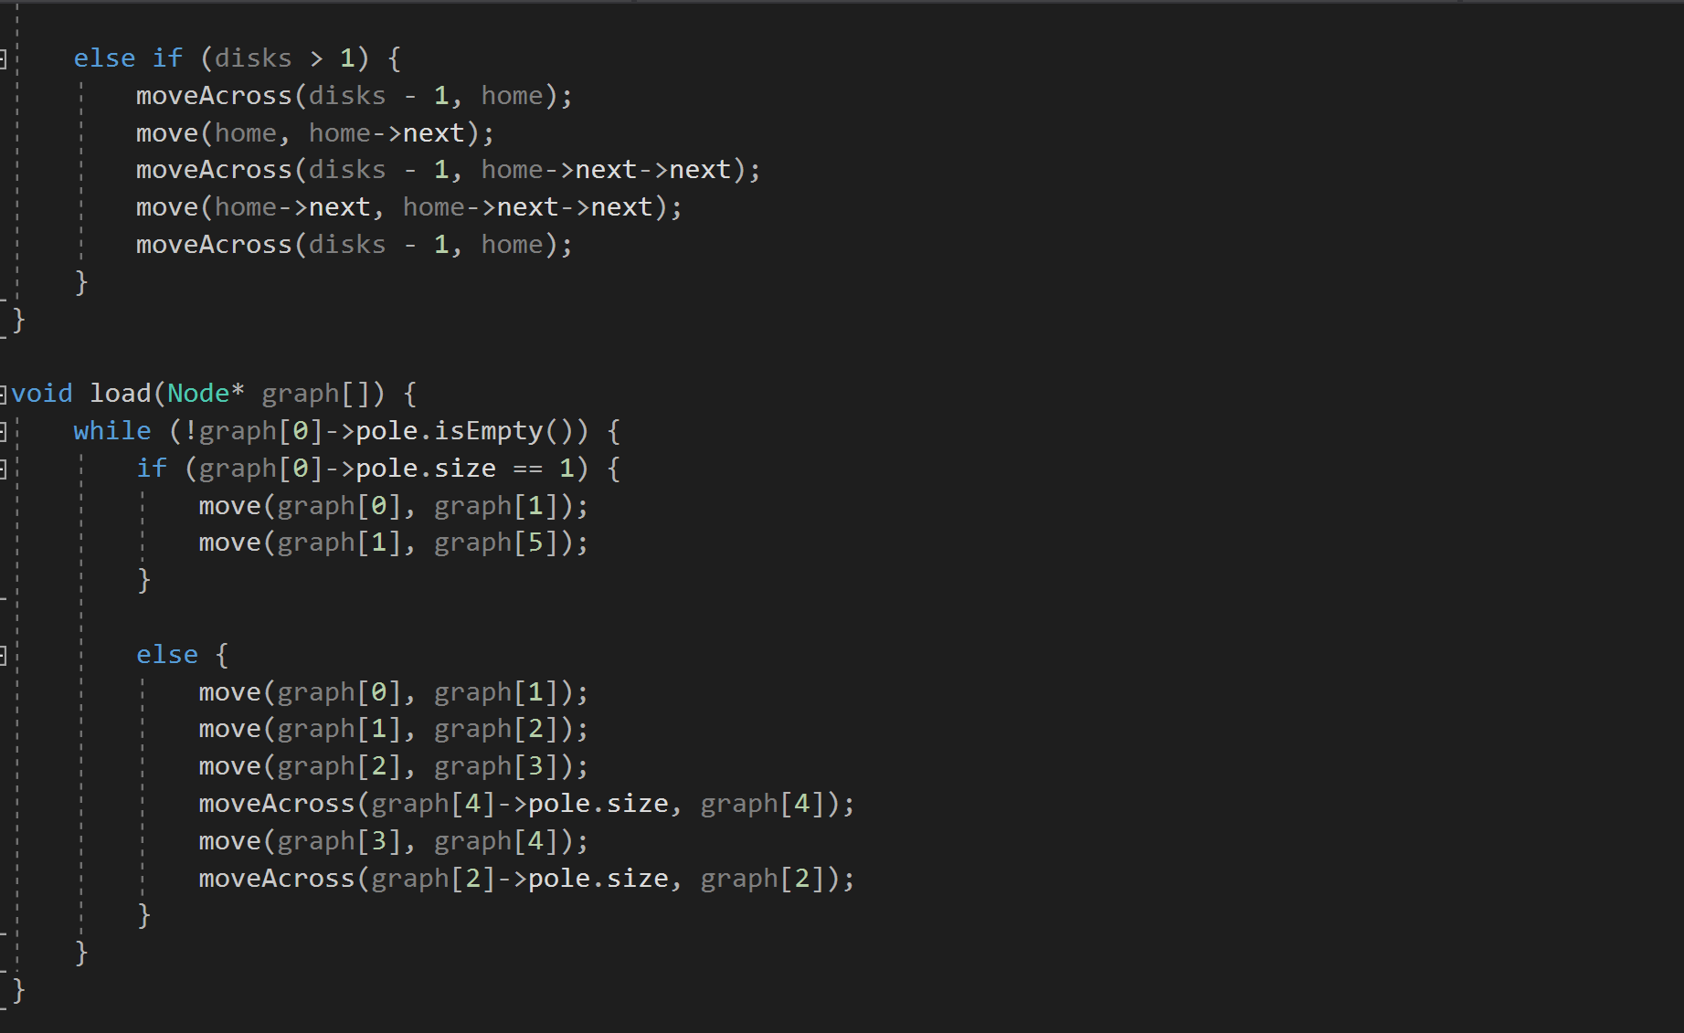

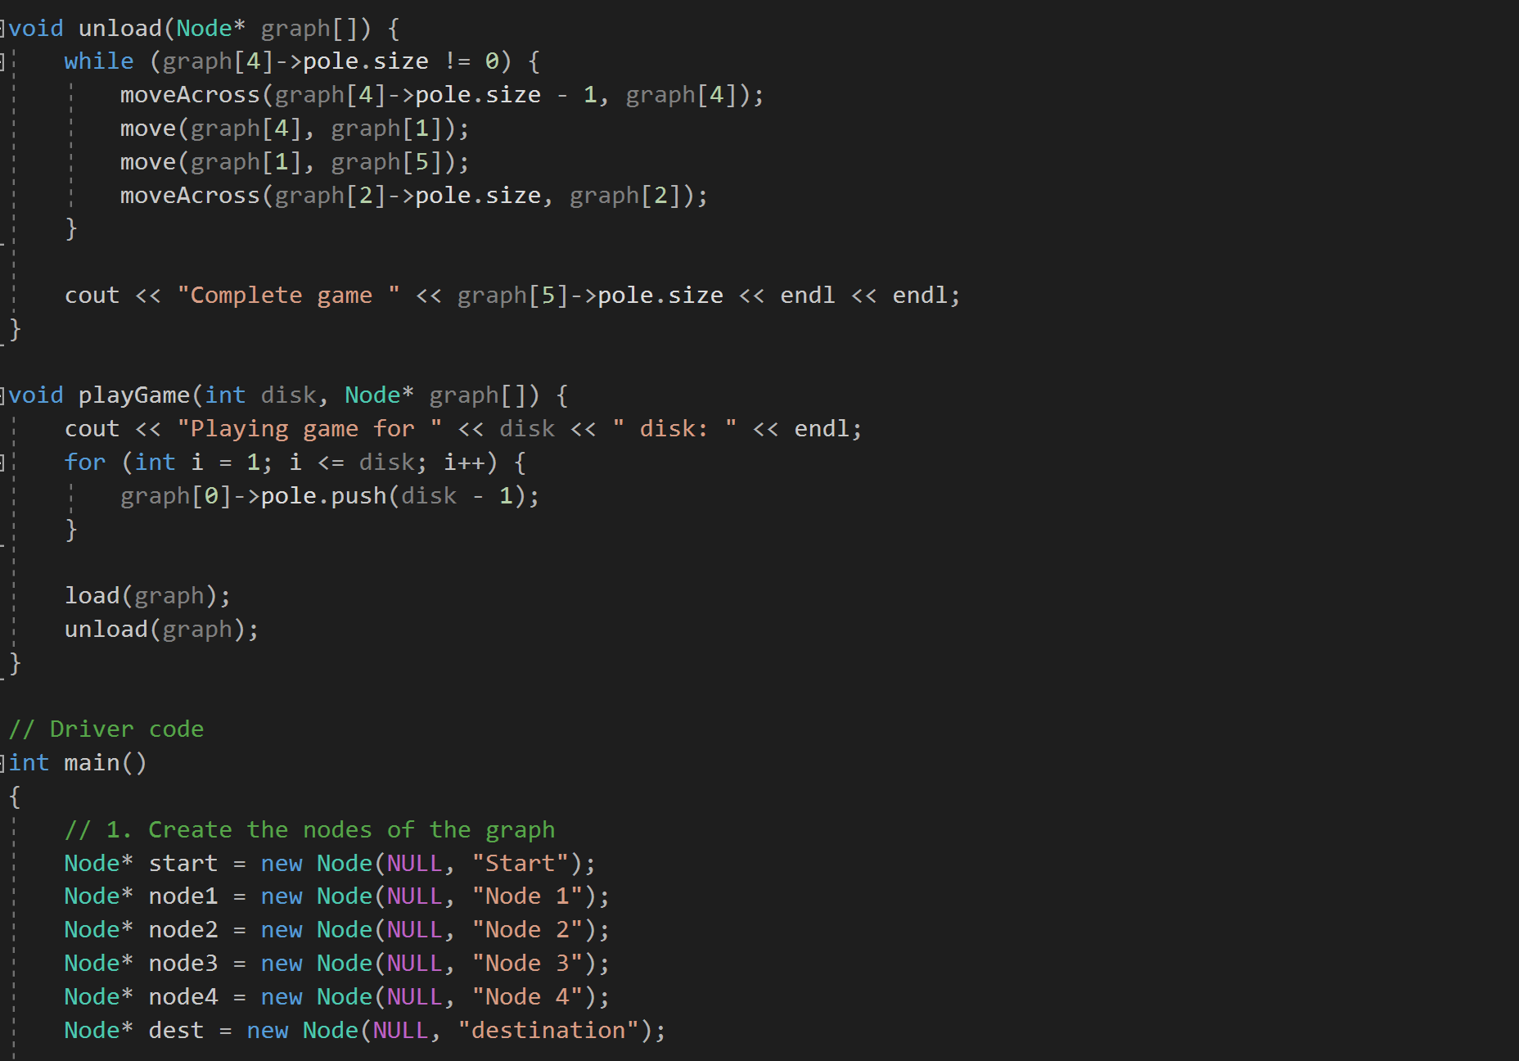

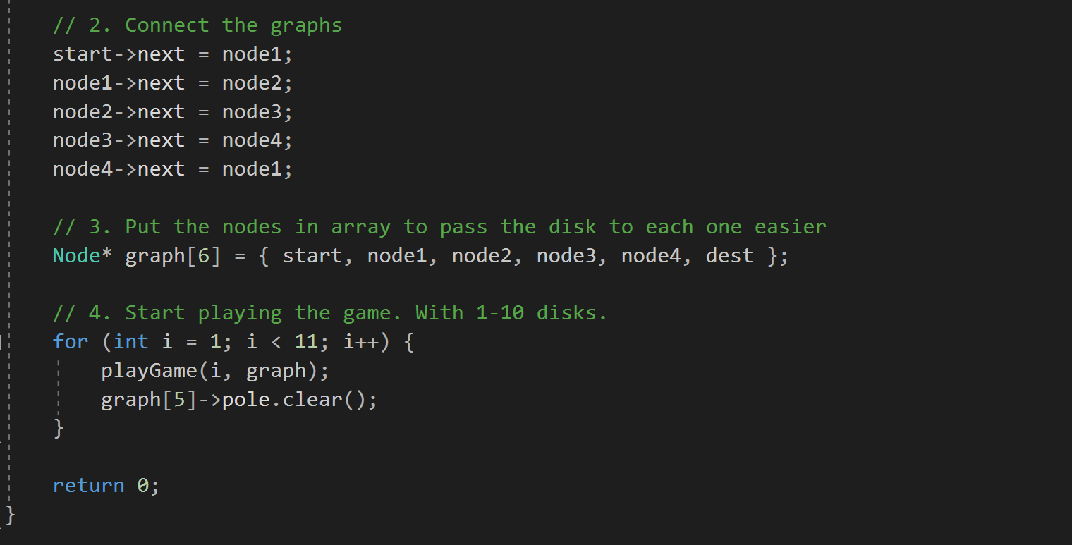

|  |
| --- |
|  |

|  |  |
| --- | --- |
|  | Playing game for 1 disks:  Move disk #1 from Start to Node 1 |
|  | Move disk #1 from Node 1 to destination |
|  | Completed game 1 |
|  |  |
|  | Playing game for 2 disks: |
|  | Move disk #1 from Start to Node 1 |
|  | Move disk #1 from Node 1 to Node 2 |
|  | Move disk #1 from Node 2 to Node 3 |
|  | Move disk #1 from Node 3 to Node 4 |
|  | Move disk #2 from Start to Node 1 |
|  | Move disk #2 from Node 1 to destination |
|  | Move disk #1 from Node 4 to Node 1 |
|  | Move disk #1 from Node 1 to destination |
|  | Completed game 2 |
|  |  |
|  | Playing game for 3 disks: |
|  | Move disk #1 from Start to Node 1 |
|  | Move disk #1 from Node 1 to Node 2 |
|  | Move disk #1 from Node 2 to Node 3 |
|  | Move disk #1 from Node 3 to Node 4 |
|  | Move disk #2 from Start to Node 1 |
|  | Move disk #2 from Node 1 to Node 2 |
|  | Move disk #2 from Node 2 to Node 3 |
|  | Move disk #1 from Node 4 to Node 1 |
|  | Move disk #1 from Node 1 to Node 2 |
|  | Move disk #2 from Node 3 to Node 4 |
|  | Move disk #1 from Node 2 to Node 3 |
|  | Move disk #1 from Node 3 to Node 4 |
|  | Move disk #3 from Start to Node 1 |
|  | Move disk #3 from Node 1 to destination |
|  | Move disk #1 from Node 4 to Node 1 |
|  | Move disk #1 from Node 1 to Node 2 |
|  | Move disk #2 from Node 4 to Node 1 |
|  | Move disk #2 from Node 1 to destination |
|  | Move disk #1 from Node 2 to Node 3 |
|  | Move disk #1 from Node 3 to Node 4 |
|  | Move disk #1 from Node 4 to Node 1 |
|  | Move disk #1 from Node 1 to destination |
|  | Completed game 3 |
|  |  |
|  | Playing game for 4 disks: |
|  | Move disk #1 from Start to Node 1 |
|  | Move disk #1 from Node 1 to Node 2 |
|  | Move disk #1 from Node 2 to Node 3 |
|  | Move disk #1 from Node 3 to Node 4 |
|  | Move disk #2 from Start to Node 1 |
|  | Move disk #2 from Node 1 to Node 2 |
|  | Move disk #2 from Node 2 to Node 3 |
|  | Move disk #1 from Node 4 to Node 1 |
|  | Move disk #1 from Node 1 to Node 2 |
|  | Move disk #2 from Node 3 to Node 4 |
|  | Move disk #1 from Node 2 to Node 3 |
|  | Move disk #1 from Node 3 to Node 4 |
|  | Move disk #3 from Start to Node 1 |
|  | Move disk #3 from Node 1 to Node 2 |
|  | Move disk #3 from Node 2 to Node 3 |
|  | Move disk #1 from Node 4 to Node 1 |
|  | Move disk #1 from Node 1 to Node 2 |
|  | Move disk #2 from Node 4 to Node 1 |
|  | Move disk #1 from Node 2 to Node 3 |
|  | Move disk #1 from Node 3 to Node 4 |
|  | Move disk #2 from Node 1 to Node 2 |
|  | Move disk #1 from Node 4 to Node 1 |
|  | Move disk #1 from Node 1 to Node 2 |
|  | Move disk #3 from Node 3 to Node 4 |
|  | Move disk #1 from Node 2 to Node 3 |
|  | Move disk #1 from Node 3 to Node 4 |
|  | Move disk #2 from Node 2 to Node 3 |
|  | Move disk #1 from Node 4 to Node 1 |
|  | Move disk #1 from Node 1 to Node 2 |
|  | Move disk #2 from Node 3 to Node 4 |
|  | Move disk #1 from Node 2 to Node 3 |
|  | Move disk #1 from Node 3 to Node 4 |
|  | Move disk #4 from Start to Node 1 |
|  | Move disk #4 from Node 1 to destination |
|  | Move disk #1 from Node 4 to Node 1 |
|  | Move disk #1 from Node 1 to Node 2 |
|  | Move disk #2 from Node 4 to Node 1 |
|  | Move disk #1 from Node 2 to Node 3 |
|  | Move disk #1 from Node 3 to Node 4 |
|  | Move disk #2 from Node 1 to Node 2 |
|  | Move disk #1 from Node 4 to Node 1 |
|  | Move disk #1 from Node 1 to Node 2 |
|  | Move disk #3 from Node 4 to Node 1 |
|  | Move disk #3 from Node 1 to destination |
|  | Move disk #1 from Node 2 to Node 3 |
|  | Move disk #1 from Node 3 to Node 4 |
|  | Move disk #2 from Node 2 to Node 3 |
|  | Move disk #1 from Node 4 to Node 1 |
|  | Move disk #1 from Node 1 to Node 2 |
|  | Move disk #2 from Node 3 to Node 4 |
|  | Move disk #1 from Node 2 to Node 3 |
|  | Move disk #1 from Node 3 to Node 4 |
|  | Move disk #1 from Node 4 to Node 1 |
|  | Move disk #1 from Node 1 to Node 2 |
|  | Move disk #2 from Node 4 to Node 1 |
|  | Move disk #2 from Node 1 to destination |
|  | Move disk #1 from Node 2 to Node 3 |
|  | Move disk #1 from Node 3 to Node 4 |
|  | Move disk #1 from Node 4 to Node 1 |
|  | Move disk #1 from Node 1 to destination |
|  | Completed game 4 |
|  |  |
|  | Playing game for 5 disks: |
|  | Move disk #1 from Start to Node 1 |
|  | Move disk #1 from Node 1 to Node 2 |
|  | Move disk #1 from Node 2 to Node 3 |
|  | Move disk #1 from Node 3 to Node 4 |
|  | Move disk #2 from Start to Node 1 |
|  | Move disk #2 from Node 1 to Node 2 |
|  | Move disk #2 from Node 2 to Node 3 |
|  | Move disk #1 from Node 4 to Node 1 |
|  | Move disk #1 from Node 1 to Node 2 |
|  | Move disk #2 from Node 3 to Node 4 |
|  | Move disk #1 from Node 2 to Node 3 |
|  | Move disk #1 from Node 3 to Node 4 |
|  | Move disk #3 from Start to Node 1 |
|  | Move disk #3 from Node 1 to Node 2 |
|  | Move disk #3 from Node 2 to Node 3 |
|  | Move disk #1 from Node 4 to Node 1 |
|  | Move disk #1 from Node 1 to Node 2 |
|  | Move disk #2 from Node 4 to Node 1 |
|  | Move disk #1 from Node 2 to Node 3 |
|  | Move disk #1 from Node 3 to Node 4 |
|  | Move disk #2 from Node 1 to Node 2 |
|  | Move disk #1 from Node 4 to Node 1 |
|  | Move disk #1 from Node 1 to Node 2 |
|  | Move disk #3 from Node 3 to Node 4 |
|  | Move disk #1 from Node 2 to Node 3 |
|  | Move disk #1 from Node 3 to Node 4 |
|  | Move disk #2 from Node 2 to Node 3 |
|  | Move disk #1 from Node 4 to Node 1 |
|  | Move disk #1 from Node 1 to Node 2 |
|  | Move disk #2 from Node 3 to Node 4 |
|  | Move disk #1 from Node 2 to Node 3 |
|  | Move disk #1 from Node 3 to Node 4 |
|  | Move disk #4 from Start to Node 1 |
|  | Move disk #4 from Node 1 to Node 2 |
|  | Move disk #4 from Node 2 to Node 3 |
|  | Move disk #1 from Node 4 to Node 1 |
|  | Move disk #1 from Node 1 to Node 2 |
|  | Move disk #2 from Node 4 to Node 1 |
|  | Move disk #1 from Node 2 to Node 3 |
|  | Move disk #1 from Node 3 to Node 4 |
|  | Move disk #2 from Node 1 to Node 2 |
|  | Move disk #1 from Node 4 to Node 1 |
|  | Move disk #1 from Node 1 to Node 2 |
|  | Move disk #3 from Node 4 to Node 1 |
|  | Move disk #1 from Node 2 to Node 3 |
|  | Move disk #1 from Node 3 to Node 4 |
|  | Move disk #2 from Node 2 to Node 3 |
|  | Move disk #1 from Node 4 to Node 1 |
|  | Move disk #1 from Node 1 to Node 2 |
|  | Move disk #2 from Node 3 to Node 4 |
|  | Move disk #1 from Node 2 to Node 3 |
|  | Move disk #1 from Node 3 to Node 4 |
|  | Move disk #3 from Node 1 to Node 2 |
|  | Move disk #1 from Node 4 to Node 1 |
|  | Move disk #1 from Node 1 to Node 2 |
|  | Move disk #2 from Node 4 to Node 1 |
|  | Move disk #1 from Node 2 to Node 3 |
|  | Move disk #1 from Node 3 to Node 4 |
|  | Move disk #2 from Node 1 to Node 2 |
|  | Move disk #1 from Node 4 to Node 1 |
|  | Move disk #1 from Node 1 to Node 2 |
|  | Move disk #4 from Node 3 to Node 4 |
|  | Move disk #1 from Node 2 to Node 3 |
|  | Move disk #1 from Node 3 to Node 4 |
|  | Move disk #2 from Node 2 to Node 3 |
|  | Move disk #1 from Node 4 to Node 1 |
|  | Move disk #1 from Node 1 to Node 2 |
|  | Move disk #2 from Node 3 to Node 4 |
|  | Move disk #1 from Node 2 to Node 3 |
|  | Move disk #1 from Node 3 to Node 4 |
|  | Move disk #3 from Node 2 to Node 3 |
|  | Move disk #1 from Node 4 to Node 1 |
|  | Move disk #1 from Node 1 to Node 2 |
|  | Move disk #2 from Node 4 to Node 1 |
|  | Move disk #1 from Node 2 to Node 3 |
|  | Move disk #1 from Node 3 to Node 4 |
|  | Move disk #2 from Node 1 to Node 2 |
|  | Move disk #1 from Node 4 to Node 1 |
|  | Move disk #1 from Node 1 to Node 2 |
|  | Move disk #3 from Node 3 to Node 4 |
|  | Move disk #1 from Node 2 to Node 3 |
|  | Move disk #1 from Node 3 to Node 4 |
|  | Move disk #2 from Node 2 to Node 3 |
|  | Move disk #1 from Node 4 to Node 1 |
|  | Move disk #1 from Node 1 to Node 2 |
|  | Move disk #2 from Node 3 to Node 4 |
|  | Move disk #1 from Node 2 to Node 3 |
|  | Move disk #1 from Node 3 to Node 4 |
|  | Move disk #5 from Start to Node 1 |
|  | Move disk #5 from Node 1 to destination |
|  | Move disk #1 from Node 4 to Node 1 |
|  | Move disk #1 from Node 1 to Node 2 |
|  | Move disk #2 from Node 4 to Node 1 |
|  | Move disk #1 from Node 2 to Node 3 |
|  | Move disk #1 from Node 3 to Node 4 |
|  | Move disk #2 from Node 1 to Node 2 |
|  | Move disk #1 from Node 4 to Node 1 |
|  | Move disk #1 from Node 1 to Node 2 |
|  | Move disk #3 from Node 4 to Node 1 |
|  | Move disk #1 from Node 2 to Node 3 |
|  | Move disk #1 from Node 3 to Node 4 |
|  | Move disk #2 from Node 2 to Node 3 |
|  | Move disk #1 from Node 4 to Node 1 |
|  | Move disk #1 from Node 1 to Node 2 |
|  | Move disk #2 from Node 3 to Node 4 |
|  | Move disk #1 from Node 2 to Node 3 |
|  | Move disk #1 from Node 3 to Node 4 |
|  | Move disk #3 from Node 1 to Node 2 |
|  | Move disk #1 from Node 4 to Node 1 |
|  | Move disk #1 from Node 1 to Node 2 |
|  | Move disk #2 from Node 4 to Node 1 |
|  | Move disk #1 from Node 2 to Node 3 |
|  | Move disk #1 from Node 3 to Node 4 |
|  | Move disk #2 from Node 1 to Node 2 |
|  | Move disk #1 from Node 4 to Node 1 |
|  | Move disk #1 from Node 1 to Node 2 |
|  | Move disk #4 from Node 4 to Node 1 |
|  | Move disk #4 from Node 1 to destination |
|  | Move disk #1 from Node 2 to Node 3 |
|  | Move disk #1 from Node 3 to Node 4 |
|  | Move disk #2 from Node 2 to Node 3 |
|  | Move disk #1 from Node 4 to Node 1 |
|  | Move disk #1 from Node 1 to Node 2 |
|  | Move disk #2 from Node 3 to Node 4 |
|  | Move disk #1 from Node 2 to Node 3 |
|  | Move disk #1 from Node 3 to Node 4 |
|  | Move disk #3 from Node 2 to Node 3 |
|  | Move disk #1 from Node 4 to Node 1 |
|  | Move disk #1 from Node 1 to Node 2 |
|  | Move disk #2 from Node 4 to Node 1 |
|  | Move disk #1 from Node 2 to Node 3 |
|  | Move disk #1 from Node 3 to Node 4 |
|  | Move disk #2 from Node 1 to Node 2 |
|  | Move disk #1 from Node 4 to Node 1 |
|  | Move disk #1 from Node 1 to Node 2 |
|  | Move disk #3 from Node 3 to Node 4 |
|  | Move disk #1 from Node 2 to Node 3 |
|  | Move disk #1 from Node 3 to Node 4 |
|  | Move disk #2 from Node 2 to Node 3 |
|  | Move disk #1 from Node 4 to Node 1 |
|  | Move disk #1 from Node 1 to Node 2 |
|  | Move disk #2 from Node 3 to Node 4 |
|  | Move disk #1 from Node 2 to Node 3 |
|  | Move disk #1 from Node 3 to Node 4 |
|  | Move disk #1 from Node 4 to Node 1 |
|  | Move disk #1 from Node 1 to Node 2 |
|  | Move disk #2 from Node 4 to Node 1 |
|  | Move disk #1 from Node 2 to Node 3 |
|  | Move disk #1 from Node 3 to Node 4 |
|  | Move disk #2 from Node 1 to Node 2 |
|  | Move disk #1 from Node 4 to Node 1 |
|  | Move disk #1 from Node 1 to Node 2 |
|  | Move disk #3 from Node 4 to Node 1 |
|  | Move disk #3 from Node 1 to destination |
|  | Move disk #1 from Node 2 to Node 3 |
|  | Move disk #1 from Node 3 to Node 4 |
|  | Move disk #2 from Node 2 to Node 3 |
|  | Move disk #1 from Node 4 to Node 1 |
|  | Move disk #1 from Node 1 to Node 2 |
|  | Move disk #2 from Node 3 to Node 4 |
|  | Move disk #1 from Node 2 to Node 3 |
|  | Move disk #1 from Node 3 to Node 4 |
|  | Move disk #1 from Node 4 to Node 1 |
|  | Move disk #1 from Node 1 to Node 2 |
|  | Move disk #2 from Node 4 to Node 1 |
|  | Move disk #2 from Node 1 to destination |
|  | Move disk #1 from Node 2 to Node 3 |
|  | Move disk #1 from Node 3 to Node 4 |
|  | Move disk #1 from Node 4 to Node 1 |
|  | Move disk #1 from Node 1 to destination |
|  | Completed game 5 |
|  |  |
|  | Playing game for 6 disks: |
|  | Move disk #1 from Start to Node 1 |
|  | Move disk #1 from Node 1 to Node 2 |
|  | Move disk #1 from Node 2 to Node 3 |
|  | Move disk #1 from Node 3 to Node 4 |
|  | Move disk #2 from Start to Node 1 |
|  | Move disk #2 from Node 1 to Node 2 |
|  | Move disk #2 from Node 2 to Node 3 |
|  | Move disk #1 from Node 4 to Node 1 |
|  | Move disk #1 from Node 1 to Node 2 |
|  | Move disk #2 from Node 3 to Node 4 |
|  | Move disk #1 from Node 2 to Node 3 |
|  | Move disk #1 from Node 3 to Node 4 |
|  | Move disk #3 from Start to Node 1 |
|  | Move disk #3 from Node 1 to Node 2 |
|  | Move disk #3 from Node 2 to Node 3 |
|  | Move disk #1 from Node 4 to Node 1 |
|  | Move disk #1 from Node 1 to Node 2 |
|  | Move disk #2 from Node 4 to Node 1 |
|  | Move disk #1 from Node 2 to Node 3 |
|  | Move disk #1 from Node 3 to Node 4 |
|  | Move disk #2 from Node 1 to Node 2 |
|  | Move disk #1 from Node 4 to Node 1 |
|  | Move disk #1 from Node 1 to Node 2 |
|  | Move disk #3 from Node 3 to Node 4 |
|  | Move disk #1 from Node 2 to Node 3 |
|  | Move disk #1 from Node 3 to Node 4 |
|  | Move disk #2 from Node 2 to Node 3 |
|  | Move disk #1 from Node 4 to Node 1 |
|  | Move disk #1 from Node 1 to Node 2 |
|  | Move disk #2 from Node 3 to Node 4 |
|  | Move disk #1 from Node 2 to Node 3 |
|  | Move disk #1 from Node 3 to Node 4 |
|  | Move disk #4 from Start to Node 1 |
|  | Move disk #4 from Node 1 to Node 2 |
|  | Move disk #4 from Node 2 to Node 3 |
|  | Move disk #1 from Node 4 to Node 1 |
|  | Move disk #1 from Node 1 to Node 2 |
|  | Move disk #2 from Node 4 to Node 1 |
|  | Move disk #1 from Node 2 to Node 3 |
|  | Move disk #1 from Node 3 to Node 4 |
|  | Move disk #2 from Node 1 to Node 2 |
|  | Move disk #1 from Node 4 to Node 1 |
|  | Move disk #1 from Node 1 to Node 2 |
|  | Move disk #3 from Node 4 to Node 1 |
|  | Move disk #1 from Node 2 to Node 3 |
|  | Move disk #1 from Node 3 to Node 4 |
|  | Move disk #2 from Node 2 to Node 3 |
|  | Move disk #1 from Node 4 to Node 1 |
|  | Move disk #1 from Node 1 to Node 2 |
|  | Move disk #2 from Node 3 to Node 4 |
|  | Move disk #1 from Node 2 to Node 3 |
|  | Move disk #1 from Node 3 to Node 4 |
|  | Move disk #3 from Node 1 to Node 2 |
|  | Move disk #1 from Node 4 to Node 1 |
|  | Move disk #1 from Node 1 to Node 2 |
|  | Move disk #2 from Node 4 to Node 1 |
|  | Move disk #1 from Node 2 to Node 3 |
|  | Move disk #1 from Node 3 to Node 4 |
|  | Move disk #2 from Node 1 to Node 2 |
|  | Move disk #1 from Node 4 to Node 1 |
|  | Move disk #1 from Node 1 to Node 2 |
|  | Move disk #4 from Node 3 to Node 4 |
|  | Move disk #1 from Node 2 to Node 3 |
|  | Move disk #1 from Node 3 to Node 4 |
|  | Move disk #2 from Node 2 to Node 3 |
|  | Move disk #1 from Node 4 to Node 1 |
|  | Move disk #1 from Node 1 to Node 2 |
|  | Move disk #2 from Node 3 to Node 4 |
|  | Move disk #1 from Node 2 to Node 3 |
|  | Move disk #1 from Node 3 to Node 4 |
|  | Move disk #3 from Node 2 to Node 3 |
|  | Move disk #1 from Node 4 to Node 1 |
|  | Move disk #1 from Node 1 to Node 2 |
|  | Move disk #2 from Node 4 to Node 1 |
|  | Move disk #1 from Node 2 to Node 3 |
|  | Move disk #1 from Node 3 to Node 4 |
|  | Move disk #2 from Node 1 to Node 2 |
|  | Move disk #1 from Node 4 to Node 1 |
|  | Move disk #1 from Node 1 to Node 2 |
|  | Move disk #3 from Node 3 to Node 4 |
|  | Move disk #1 from Node 2 to Node 3 |
|  | Move disk #1 from Node 3 to Node 4 |
|  | Move disk #2 from Node 2 to Node 3 |
|  | Move disk #1 from Node 4 to Node 1 |
|  | Move disk #1 from Node 1 to Node 2 |
|  | Move disk #2 from Node 3 to Node 4 |
|  | Move disk #1 from Node 2 to Node 3 |
|  | Move disk #1 from Node 3 to Node 4 |
|  | Move disk #5 from Start to Node 1 |
|  | Move disk #5 from Node 1 to Node 2 |
|  | Move disk #5 from Node 2 to Node 3 |
|  | Move disk #1 from Node 4 to Node 1 |
|  | Move disk #1 from Node 1 to Node 2 |
|  | Move disk #2 from Node 4 to Node 1 |
|  | Move disk #1 from Node 2 to Node 3 |
|  | Move disk #1 from Node 3 to Node 4 |
|  | Move disk #2 from Node 1 to Node 2 |
|  | Move disk #1 from Node 4 to Node 1 |
|  | Move disk #1 from Node 1 to Node 2 |
|  | Move disk #1 from Node 3 to Node 4 |
|  | Move disk #3 from Node 2 to Node 3 |
|  | Move disk #1 from Node 4 to Node 1 |
|  | Move disk #1 from Node 1 to Node 2 |
|  | Move disk #2 from Node 4 to Node 1 |
|  | Move disk #1 from Node 2 to Node 3 |
|  | Move disk #1 from Node 3 to Node 4 |
|  | Move disk #2 from Node 1 to Node 2 |
|  | Move disk #1 from Node 4 to Node 1 |
|  | Move disk #1 from Node 1 to Node 2 |
|  | Move disk #3 from Node 3 to Node 4 |
|  | Move disk #1 from Node 2 to Node 3 |
|  | Move disk #1 from Node 3 to Node 4 |
|  | Move disk #2 from Node 2 to Node 3 |
|  | Move disk #1 from Node 4 to Node 1 |
|  | Move disk #1 from Node 1 to Node 2 |
|  | Move disk #2 from Node 3 to Node 4 |
|  | Move disk #1 from Node 2 to Node 3 |
|  | Move disk #1 from Node 3 to Node 4 |
|  | Move disk #1 from Node 4 to Node 1 |
|  | Move disk #1 from Node 1 to Node 2 |
|  | Move disk #2 from Node 4 to Node 1 |
|  | Move disk #1 from Node 2 to Node 3 |
|  | Move disk #1 from Node 3 to Node 4 |
|  | Move disk #2 from Node 1 to Node 2 |
|  | Move disk #1 from Node 4 to Node 1 |
|  | Move disk #1 from Node 1 to Node 2 |
|  | Move disk #3 from Node 4 to Node 1 |
|  | Move disk #1 from Node 2 to Node 3 |
|  | Move disk #1 from Node 3 to Node 4 |
|  | Move disk #2 from Node 2 to Node 3 |
|  | Move disk #1 from Node 4 to Node 1 |
|  | Move disk #1 from Node 1 to Node 2 |
|  | Move disk #2 from Node 3 to Node 4 |
|  | Move disk #1 from Node 2 to Node 3 |
|  | Move disk #1 from Node 3 to Node 4 |
|  | Move disk #3 from Node 1 to Node 2 |
|  | Move disk #1 from Node 4 to Node 1 |
|  | Move disk #1 from Node 1 to Node 2 |
|  | Move disk #2 from Node 4 to Node 1 |
|  | Move disk #1 from Node 2 to Node 3 |
|  | Move disk #1 from Node 3 to Node 4 |
|  | Move disk #2 from Node 1 to Node 2 |
|  | Move disk #1 from Node 4 to Node 1 |
|  | Move disk #1 from Node 1 to Node 2 |
|  | Move disk #4 from Node 4 to Node 1 |
|  | Move disk #4 from Node 1 to destination |
|  | Move disk #1 from Node 2 to Node 3 |
|  | Move disk #1 from Node 3 to Node 4 |
|  | Move disk #2 from Node 2 to Node 3 |
|  | Move disk #1 from Node 4 to Node 1 |
|  | Move disk #1 from Node 1 to Node 2 |
|  | Move disk #2 from Node 3 to Node 4 |
|  | Move disk #1 from Node 2 to Node 3 |
|  | Move disk #1 from Node 3 to Node 4 |
|  | Move disk #3 from Node 2 to Node 3 |
|  | Move disk #1 from Node 4 to Node 1 |
|  | Move disk #1 from Node 1 to Node 2 |
|  | Move disk #2 from Node 4 to Node 1 |
|  | Move disk #1 from Node 2 to Node 3 |
|  | Move disk #1 from Node 3 to Node 4 |
|  | Move disk #2 from Node 1 to Node 2 |
|  | Move disk #1 from Node 4 to Node 1 |
|  | Move disk #1 from Node 1 to Node 2 |
|  | Move disk #3 from Node 3 to Node 4 |
|  | Move disk #1 from Node 2 to Node 3 |
|  | Move disk #1 from Node 3 to Node 4 |
|  | Move disk #2 from Node 2 to Node 3 |
|  | Move disk #1 from Node 4 to Node 1 |
|  | Move disk #1 from Node 1 to Node 2 |
|  | Move disk #2 from Node 3 to Node 4 |
|  | Move disk #1 from Node 2 to Node 3 |
|  | Move disk #1 from Node 3 to Node 4 |
|  | Move disk #1 from Node 4 to Node 1 |
|  | Move disk #1 from Node 1 to Node 2 |
|  | Move disk #2 from Node 4 to Node 1 |
|  | Move disk #1 from Node 2 to Node 3 |
|  | Move disk #1 from Node 3 to Node 4 |
|  | Move disk #2 from Node 1 to Node 2 |
|  | Move disk #1 from Node 4 to Node 1 |
|  | Move disk #1 from Node 1 to Node 2 |
|  | Move disk #3 from Node 4 to Node 1 |
|  | Move disk #3 from Node 1 to destination |
|  | Move disk #1 from Node 2 to Node 3 |
|  | Move disk #1 from Node 3 to Node 4 |
|  | Move disk #2 from Node 2 to Node 3 |
|  | Move disk #1 from Node 4 to Node 1 |
|  | Move disk #1 from Node 1 to Node 2 |
|  | Move disk #2 from Node 3 to Node 4 |
|  | Move disk #1 from Node 2 to Node 3 |
|  | Move disk #1 from Node 3 to Node 4 |
|  | Move disk #1 from Node 4 to Node 1 |
|  | Move disk #1 from Node 1 to Node 2 |
|  | Move disk #2 from Node 4 to Node 1 |
|  | Move disk #2 from Node 1 to destination |
|  | Move disk #1 from Node 2 to Node 3 |
|  | Move disk #1 from Node 3 to Node 4 |
|  | Move disk #1 from Node 4 to Node 1 |
|  | Move disk #1 from Node 1 to destination |
|  | Completed game 6 |
|  |  |
|  | Playing game for 7 disks: |
|  | Move disk #1 from Start to Node 1 |
|  | Move disk #1 from Node 1 to Node 2 |
|  | Move disk #1 from Node 2 to Node 3 |
|  | Move disk #1 from Node 3 to Node 4 |
|  | Move disk #2 from Start to Node 1 |
|  | Move disk #2 from Node 1 to Node 2 |
|  | Move disk #2 from Node 2 to Node 3 |
|  | Move disk #1 from Node 4 to Node 1 |
|  | Move disk #1 from Node 1 to Node 2 |
|  | Move disk #2 from Node 3 to Node 4 |
|  | Move disk #1 from Node 2 to Node 3 |
|  | Move disk #1 from Node 3 to Node 4 |
|  | Move disk #3 from Start to Node 1 |
|  | Move disk #3 from Node 1 to Node 2 |
|  | Move disk #3 from Node 2 to Node 3 |
|  | Move disk #1 from Node 4 to Node 1 |
|  | Move disk #1 from Node 1 to Node 2 |
|  | Move disk #2 from Node 4 to Node 1 |
|  | Move disk #1 from Node 2 to Node 3 |
|  | Move disk #1 from Node 3 to Node 4 |
|  | Move disk #2 from Node 1 to Node 2 |
|  | Move disk #1 from Node 4 to Node 1 |
|  | Move disk #1 from Node 1 to Node 2 |
|  | Move disk #3 from Node 3 to Node 4 |
|  | Move disk #1 from Node 2 to Node 3 |
|  | Move disk #1 from Node 3 to Node 4 |
|  | Move disk #2 from Node 2 to Node 3 |
|  | Move disk #1 from Node 4 to Node 1 |
|  | Move disk #1 from Node 1 to Node 2 |
|  | Move disk #2 from Node 3 to Node 4 |
|  | Move disk #1 from Node 2 to Node 3 |
|  | Move disk #1 from Node 3 to Node 4 |
|  | Move disk #4 from Start to Node 1 |
|  | Move disk #4 from Node 1 to Node 2 |
|  | Move disk #4 from Node 2 to Node 3 |
|  | Move disk #1 from Node 4 to Node 1 |
|  | Move disk #1 from Node 1 to Node 2 |
|  | Move disk #2 from Node 4 to Node 1 |
|  | Move disk #1 from Node 2 to Node 3 |
|  | Move disk #1 from Node 3 to Node 4 |
|  | Move disk #2 from Node 1 to Node 2 |
|  | Move disk #1 from Node 4 to Node 1 |
|  | Move disk #1 from Node 1 to Node 2 |
|  | Move disk #3 from Node 4 to Node 1 |
|  | Move disk #1 from Node 2 to Node 3 |
|  | Move disk #1 from Node 3 to Node 4 |
|  | Move disk #2 from Node 2 to Node 3 |
|  | Move disk #1 from Node 4 to Node 1 |
|  | Move disk #1 from Node 1 to Node 2 |
|  | Move disk #2 from Node 3 to Node 4 |
|  | Move disk #1 from Node 2 to Node 3 |
|  | Move disk #1 from Node 3 to Node 4 |
|  | Move disk #3 from Node 1 to Node 2 |
|  | Move disk #1 from Node 4 to Node 1 |
|  | Move disk #1 from Node 1 to Node 2 |
|  | Move disk #2 from Node 4 to Node 1 |
|  | Move disk #1 from Node 2 to Node 3 |
|  | Move disk #1 from Node 3 to Node 4 |
|  | Move disk #2 from Node 1 to Node 2 |
|  | Move disk #1 from Node 4 to Node 1 |
|  | Move disk #1 from Node 1 to Node 2 |
|  | Move disk #4 from Node 3 to Node 4 |
|  | Move disk #1 from Node 2 to Node 3 |
|  | Move disk #1 from Node 3 to Node 4 |
|  | Move disk #2 from Node 2 to Node 3 |
|  | Move disk #1 from Node 4 to Node 1 |
|  | Move disk #1 from Node 1 to Node 2 |
|  | Move disk #2 from Node 3 to Node 4 |
|  | Move disk #1 from Node 2 to Node 3 |
|  | Move disk #1 from Node 3 to Node 4 |
|  | Move disk #3 from Node 2 to Node 3 |
|  | Move disk #1 from Node 4 to Node 1 |
|  | Move disk #1 from Node 1 to Node 2 |
|  | Move disk #2 from Node 4 to Node 1 |
|  | Move disk #1 from Node 2 to Node 3 |
|  | Move disk #1 from Node 3 to Node 4 |
|  | Move disk #2 from Node 1 to Node 2 |
|  | Move disk #1 from Node 4 to Node 1 |
|  | Move disk #1 from Node 1 to Node 2 |
|  | Move disk #3 from Node 3 to Node 4 |
|  | Move disk #1 from Node 2 to Node 3 |
|  | Move disk #1 from Node 3 to Node 4 |
|  | Move disk #2 from Node 2 to Node 3 |
|  | Move disk #1 from Node 4 to Node 1 |
|  | Move disk #1 from Node 1 to Node 2 |
|  | Move disk #2 from Node 3 to Node 4 |
|  | Move disk #1 from Node 2 to Node 3 |
|  | Move disk #1 from Node 3 to Node 4 |
|  | Move disk #5 from Start to Node 1 |
|  | Move disk #5 from Node 1 to Node 2 |
|  | Move disk #5 from Node 2 to Node 3 |
|  | Move disk #1 from Node 4 to Node 1 |
|  | Move disk #1 from Node 1 to Node 2 |
|  | Move disk #2 from Node 4 to Node 1 |
|  | Move disk #1 from Node 2 to Node 3 |
|  | Move disk #1 from Node 3 to Node 4 |
|  | Move disk #2 from Node 1 to Node 2 |
|  | Move disk #1 from Node 4 to Node 1 |
|  | Move disk #1 from Node 1 to Node 2 |
|  | Move disk #1 from Node 3 to Node 4 |
|  | Move disk #3 from Node 2 to Node 3 |
|  | Move disk #1 from Node 4 to Node 1 |
|  | Move disk #1 from Node 1 to Node 2 |
|  | Move disk #2 from Node 4 to Node 1 |
|  | Move disk #1 from Node 2 to Node 3 |
|  | Move disk #1 from Node 3 to Node 4 |
|  | Move disk #2 from Node 1 to Node 2 |
|  | Move disk #1 from Node 4 to Node 1 |
|  | Move disk #1 from Node 1 to Node 2 |
|  | Move disk #3 from Node 3 to Node 4 |
|  | Move disk #1 from Node 2 to Node 3 |
|  | Move disk #1 from Node 3 to Node 4 |
|  | Move disk #2 from Node 2 to Node 3 |
|  | Move disk #1 from Node 4 to Node 1 |
|  | Move disk #1 from Node 1 to Node 2 |
|  | Move disk #2 from Node 3 to Node 4 |
|  | Move disk #1 from Node 2 to Node 3 |
|  | Move disk #1 from Node 3 to Node 4 |
|  | Move disk #1 from Node 4 to Node 1 |
|  | Move disk #1 from Node 1 to Node 2 |
|  | Move disk #2 from Node 4 to Node 1 |
|  | Move disk #1 from Node 2 to Node 3 |
|  | Move disk #1 from Node 3 to Node 4 |
|  | Move disk #2 from Node 1 to Node 2 |
|  | Move disk #1 from Node 4 to Node 1 |
|  | Move disk #1 from Node 1 to Node 2 |
|  | Move disk #3 from Node 4 to Node 1 |
|  | Move disk #1 from Node 2 to Node 3 |
|  | Move disk #1 from Node 3 to Node 4 |
|  | Move disk #2 from Node 2 to Node 3 |
|  | Move disk #1 from Node 4 to Node 1 |
|  | Move disk #1 from Node 1 to Node 2 |
|  | Move disk #2 from Node 3 to Node 4 |
|  | Move disk #1 from Node 2 to Node 3 |
|  | Move disk #1 from Node 3 to Node 4 |
|  | Move disk #3 from Node 1 to Node 2 |
|  | Move disk #1 from Node 4 to Node 1 |
|  | Move disk #1 from Node 1 to Node 2 |
|  | Move disk #2 from Node 4 to Node 1 |
|  | Move disk #1 from Node 2 to Node 3 |
|  | Move disk #1 from Node 3 to Node 4 |
|  | Move disk #2 from Node 1 to Node 2 |
|  | Move disk #1 from Node 4 to Node 1 |
|  | Move disk #1 from Node 1 to Node 2 |
|  | Move disk #4 from Node 4 to Node 1 |
|  | Move disk #4 from Node 1 to destination |
|  | Move disk #1 from Node 2 to Node 3 |
|  | Move disk #1 from Node 3 to Node 4 |
|  | Move disk #2 from Node 2 to Node 3 |
|  | Move disk #1 from Node 4 to Node 1 |
|  | Move disk #1 from Node 1 to Node 2 |
|  | Move disk #2 from Node 3 to Node 4 |
|  | Move disk #1 from Node 2 to Node 3 |
|  | Move disk #1 from Node 3 to Node 4 |
|  | Move disk #3 from Node 2 to Node 3 |
|  | Move disk #1 from Node 4 to Node 1 |
|  | Move disk #1 from Node 1 to Node 2 |
|  | Move disk #2 from Node 4 to Node 1 |
|  | Move disk #1 from Node 2 to Node 3 |
|  | Move disk #1 from Node 3 to Node 4 |
|  | Move disk #2 from Node 1 to Node 2 |
|  | Move disk #1 from Node 4 to Node 1 |
|  | Move disk #1 from Node 1 to Node 2 |
|  | Move disk #3 from Node 3 to Node 4 |
|  | Move disk #1 from Node 2 to Node 3 |
|  | Move disk #1 from Node 3 to Node 4 |
|  | Move disk #2 from Node 2 to Node 3 |
|  | Move disk #1 from Node 4 to Node 1 |
|  | Move disk #1 from Node 1 to Node 2 |
|  | Move disk #2 from Node 3 to Node 4 |
|  | Move disk #1 from Node 2 to Node 3 |
|  | Move disk #1 from Node 3 to Node 4 |
|  | Move disk #1 from Node 4 to Node 1 |
|  | Move disk #1 from Node 1 to Node 2 |
|  | Move disk #2 from Node 4 to Node 1 |
|  | Move disk #1 from Node 2 to Node 3 |
|  | Move disk #1 from Node 3 to Node 4 |
|  | Move disk #2 from Node 1 to Node 2 |
|  | Move disk #1 from Node 4 to Node 1 |
|  | Move disk #1 from Node 1 to Node 2 |
|  | Move disk #3 from Node 4 to Node 1 |
|  | Move disk #3 from Node 1 to destination |
|  | Move disk #1 from Node 2 to Node 3 |
|  | Move disk #1 from Node 3 to Node 4 |
|  | Move disk #2 from Node 2 to Node 3 |
|  | Move disk #1 from Node 4 to Node 1 |
|  | Move disk #1 from Node 1 to Node 2 |
|  | Move disk #2 from Node 3 to Node 4 |
|  | Move disk #1 from Node 2 to Node 3 |
|  | Move disk #1 from Node 3 to Node 4 |
|  | Move disk #1 from Node 4 to Node 1 |
|  | Move disk #1 from Node 1 to Node 2 |
|  | Move disk #2 from Node 4 to Node 1 |
|  | Move disk #2 from Node 1 to destination |
|  | Move disk #1 from Node 2 to Node 3 |
|  | Move disk #1 from Node 3 to Node 4 |
|  | Move disk #1 from Node 4 to Node 1 |
|  | Move disk #1 from Node 1 to destination |
|  | Completed game 7 |
|  |  |
|  | Playing game for 8 disks: |
|  | Move disk #1 from Start to Node 1 |
|  | Move disk #1 from Node 1 to Node 2 |
|  | Move disk #1 from Node 2 to Node 3 |
|  | Move disk #1 from Node 3 to Node 4 |
|  | Move disk #2 from Start to Node 1 |
|  | Move disk #2 from Node 1 to Node 2 |
|  | Move disk #2 from Node 2 to Node 3 |
|  | Move disk #1 from Node 4 to Node 1 |
|  | Move disk #1 from Node 1 to Node 2 |
|  | Move disk #2 from Node 3 to Node 4 |
|  | Move disk #1 from Node 2 to Node 3 |
|  | Move disk #1 from Node 3 to Node 4 |
|  | Move disk #3 from Start to Node 1 |
|  | Move disk #3 from Node 1 to Node 2 |
|  | Move disk #3 from Node 2 to Node 3 |
|  | Move disk #1 from Node 4 to Node 1 |
|  | Move disk #1 from Node 1 to Node 2 |
|  | Move disk #2 from Node 4 to Node 1 |
|  | Move disk #1 from Node 2 to Node 3 |
|  | Move disk #1 from Node 3 to Node 4 |
|  | Move disk #2 from Node 1 to Node 2 |
|  | Move disk #1 from Node 4 to Node 1 |
|  | Move disk #1 from Node 1 to Node 2 |
|  | Move disk #3 from Node 3 to Node 4 |
|  | Move disk #1 from Node 2 to Node 3 |
|  | Move disk #1 from Node 3 to Node 4 |
|  | Move disk #2 from Node 2 to Node 3 |
|  | Move disk #1 from Node 4 to Node 1 |
|  | Move disk #1 from Node 1 to Node 2 |
|  | Move disk #2 from Node 3 to Node 4 |
|  | Move disk #1 from Node 2 to Node 3 |
|  | Move disk #1 from Node 3 to Node 4 |
|  | Move disk #4 from Start to Node 1 |
|  | Move disk #4 from Node 1 to Node 2 |
|  | Move disk #4 from Node 2 to Node 3 |
|  | Move disk #1 from Node 4 to Node 1 |
|  | Move disk #1 from Node 1 to Node 2 |
|  | Move disk #2 from Node 4 to Node 1 |
|  | Move disk #1 from Node 2 to Node 3 |
|  | Move disk #1 from Node 3 to Node 4 |
|  | Move disk #2 from Node 1 to Node 2 |
|  | Move disk #1 from Node 4 to Node 1 |
|  | Move disk #1 from Node 1 to Node 2 |
|  | Move disk #3 from Node 4 to Node 1 |
|  | Move disk #1 from Node 2 to Node 3 |
|  | Move disk #1 from Node 3 to Node 4 |
|  | Move disk #2 from Node 2 to Node 3 |
|  | Move disk #1 from Node 4 to Node 1 |
|  | Move disk #1 from Node 1 to Node 2 |
|  | Move disk #2 from Node 3 to Node 4 |
|  | Move disk #1 from Node 2 to Node 3 |
|  | Move disk #1 from Node 3 to Node 4 |
|  | Move disk #3 from Node 1 to Node 2 |
|  | Move disk #1 from Node 4 to Node 1 |
|  | Move disk #1 from Node 1 to Node 2 |
|  | Move disk #2 from Node 4 to Node 1 |
|  | Move disk #1 from Node 2 to Node 3 |
|  | Move disk #1 from Node 3 to Node 4 |
|  | Move disk #2 from Node 1 to Node 2 |
|  | Move disk #1 from Node 4 to Node 1 |
|  | Move disk #1 from Node 1 to Node 2 |
|  | Move disk #4 from Node 3 to Node 4 |
|  | Move disk #1 from Node 2 to Node 3 |
|  | Move disk #1 from Node 3 to Node 4 |
|  | Move disk #2 from Node 2 to Node 3 |
|  | Move disk #1 from Node 4 to Node 1 |
|  | Move disk #1 from Node 1 to Node 2 |
|  | Move disk #2 from Node 3 to Node 4 |
|  | Move disk #1 from Node 2 to Node 3 |
|  | Move disk #1 from Node 3 to Node 4 |
|  | Move disk #3 from Node 2 to Node 3 |
|  | Move disk #1 from Node 4 to Node 1 |
|  | Move disk #1 from Node 1 to Node 2 |
|  | Move disk #2 from Node 4 to Node 1 |
|  | Move disk #1 from Node 2 to Node 3 |
|  | Move disk #1 from Node 3 to Node 4 |
|  | Move disk #2 from Node 1 to Node 2 |
|  | Move disk #1 from Node 4 to Node 1 |
|  | Move disk #1 from Node 1 to Node 2 |
|  | Move disk #3 from Node 3 to Node 4 |
|  | Move disk #1 from Node 2 to Node 3 |
|  | Move disk #1 from Node 3 to Node 4 |
|  | Move disk #2 from Node 2 to Node 3 |
|  | Move disk #1 from Node 4 to Node 1 |
|  | Move disk #1 from Node 1 to Node 2 |
|  | Move disk #2 from Node 3 to Node 4 |
|  | Move disk #1 from Node 2 to Node 3 |
|  | Move disk #1 from Node 3 to Node 4 |
|  | Move disk #5 from Start to Node 1 |
|  | Move disk #5 from Node 1 to Node 2 |
|  | Move disk #5 from Node 2 to Node 3 |
|  | Move disk #1 from Node 4 to Node 1 |
|  | Move disk #1 from Node 1 to Node 2 |
|  | Move disk #2 from Node 4 to Node 1 |
|  | Move disk #1 from Node 2 to Node 3 |
|  | Move disk #1 from Node 3 to Node 4 |
|  | Move disk #2 from Node 1 to Node 2 |
|  | Move disk #1 from Node 4 to Node 1 |
|  | Move disk #1 from Node 1 to Node 2 |
|  | Move disk #1 from Node 3 to Node 4 |
|  | Move disk #3 from Node 2 to Node 3 |
|  | Move disk #1 from Node 4 to Node 1 |
|  | Move disk #1 from Node 1 to Node 2 |
|  | Move disk #2 from Node 4 to Node 1 |
|  | Move disk #1 from Node 2 to Node 3 |
|  | Move disk #1 from Node 3 to Node 4 |
|  | Move disk #2 from Node 1 to Node 2 |
|  | Move disk #1 from Node 4 to Node 1 |
|  | Move disk #1 from Node 1 to Node 2 |
|  | Move disk #3 from Node 3 to Node 4 |
|  | Move disk #1 from Node 2 to Node 3 |
|  | Move disk #1 from Node 3 to Node 4 |
|  | Move disk #2 from Node 2 to Node 3 |
|  | Move disk #1 from Node 4 to Node 1 |
|  | Move disk #1 from Node 1 to Node 2 |
|  | Move disk #2 from Node 3 to Node 4 |
|  | Move disk #1 from Node 2 to Node 3 |
|  | Move disk #1 from Node 3 to Node 4 |
|  | Move disk #1 from Node 4 to Node 1 |
|  | Move disk #1 from Node 1 to Node 2 |
|  | Move disk #2 from Node 4 to Node 1 |
|  | Move disk #1 from Node 2 to Node 3 |
|  | Move disk #1 from Node 3 to Node 4 |
|  | Move disk #2 from Node 1 to Node 2 |
|  | Move disk #1 from Node 4 to Node 1 |
|  | Move disk #1 from Node 1 to Node 2 |
|  | Move disk #3 from Node 4 to Node 1 |
|  | Move disk #1 from Node 2 to Node 3 |
|  | Move disk #1 from Node 3 to Node 4 |
|  | Move disk #2 from Node 2 to Node 3 |
|  | Move disk #1 from Node 4 to Node 1 |
|  | Move disk #1 from Node 1 to Node 2 |
|  | Move disk #2 from Node 3 to Node 4 |
|  | Move disk #1 from Node 2 to Node 3 |
|  | Move disk #1 from Node 3 to Node 4 |
|  | Move disk #3 from Node 1 to Node 2 |
|  | Move disk #1 from Node 4 to Node 1 |
|  | Move disk #1 from Node 1 to Node 2 |
|  | Move disk #2 from Node 4 to Node 1 |
|  | Move disk #1 from Node 2 to Node 3 |
|  | Move disk #1 from Node 3 to Node 4 |
|  | Move disk #2 from Node 1 to Node 2 |
|  | Move disk #1 from Node 4 to Node 1 |
|  | Move disk #1 from Node 1 to Node 2 |
|  | Move disk #4 from Node 4 to Node 1 |
|  | Move disk #4 from Node 1 to destination |
|  | Move disk #1 from Node 2 to Node 3 |
|  | Move disk #1 from Node 3 to Node 4 |
|  | Move disk #2 from Node 2 to Node 3 |
|  | Move disk #1 from Node 4 to Node 1 |
|  | Move disk #1 from Node 1 to Node 2 |
|  | Move disk #2 from Node 3 to Node 4 |
|  | Move disk #1 from Node 2 to Node 3 |
|  | Move disk #1 from Node 3 to Node 4 |
|  | Move disk #3 from Node 2 to Node 3 |
|  | Move disk #1 from Node 4 to Node 1 |
|  | Move disk #1 from Node 1 to Node 2 |
|  | Move disk #2 from Node 4 to Node 1 |
|  | Move disk #1 from Node 2 to Node 3 |
|  | Move disk #1 from Node 3 to Node 4 |
|  | Move disk #2 from Node 1 to Node 2 |
|  | Move disk #1 from Node 4 to Node 1 |
|  | Move disk #1 from Node 1 to Node 2 |
|  | Move disk #3 from Node 3 to Node 4 |
|  | Move disk #1 from Node 2 to Node 3 |
|  | Move disk #1 from Node 3 to Node 4 |
|  | Move disk #2 from Node 2 to Node 3 |
|  | Move disk #1 from Node 4 to Node 1 |
|  | Move disk #1 from Node 1 to Node 2 |
|  | Move disk #2 from Node 3 to Node 4 |
|  | Move disk #1 from Node 2 to Node 3 |
|  | Move disk #1 from Node 3 to Node 4 |
|  | Move disk #1 from Node 4 to Node 1 |
|  | Move disk #1 from Node 1 to Node 2 |
|  | Move disk #2 from Node 4 to Node 1 |
|  | Move disk #1 from Node 2 to Node 3 |
|  | Move disk #1 from Node 3 to Node 4 |
|  | Move disk #2 from Node 1 to Node 2 |
|  | Move disk #1 from Node 4 to Node 1 |
|  | Move disk #1 from Node 1 to Node 2 |
|  | Move disk #3 from Node 4 to Node 1 |
|  | Move disk #3 from Node 1 to destination |
|  | Move disk #1 from Node 2 to Node 3 |
|  | Move disk #1 from Node 3 to Node 4 |
|  | Move disk #2 from Node 2 to Node 3 |
|  | Move disk #1 from Node 4 to Node 1 |
|  | Move disk #1 from Node 1 to Node 2 |
|  | Move disk #2 from Node 3 to Node 4 |
|  | Move disk #1 from Node 2 to Node 3 |
|  | Move disk #1 from Node 3 to Node 4 |
|  | Move disk #1 from Node 4 to Node 1 |
|  | Move disk #1 from Node 1 to Node 2 |
|  | Move disk #2 from Node 4 to Node 1 |
|  | Move disk #2 from Node 1 to destination |
|  | Move disk #1 from Node 2 to Node 3 |
|  | Move disk #1 from Node 3 to Node 4 |
|  | Move disk #1 from Node 4 to Node 1 |
|  | Move disk #1 from Node 1 to destination |
|  | Completed game 8 |
|  |  |
|  | Playing game for 9 disks: |
|  | Move disk #1 from Start to Node 1 |
|  | Move disk #1 from Node 1 to Node 2 |
|  | Move disk #1 from Node 2 to Node 3 |
|  | Move disk #1 from Node 3 to Node 4 |
|  | Move disk #2 from Start to Node 1 |
|  | Move disk #2 from Node 1 to Node 2 |
|  | Move disk #2 from Node 2 to Node 3 |
|  | Move disk #1 from Node 4 to Node 1 |
|  | Move disk #1 from Node 1 to Node 2 |
|  | Move disk #2 from Node 3 to Node 4 |
|  | Move disk #1 from Node 2 to Node 3 |
|  | Move disk #1 from Node 3 to Node 4 |
|  | Move disk #3 from Start to Node 1 |
|  | Move disk #3 from Node 1 to Node 2 |
|  | Move disk #3 from Node 2 to Node 3 |
|  | Move disk #1 from Node 4 to Node 1 |
|  | Move disk #1 from Node 1 to Node 2 |
|  | Move disk #2 from Node 4 to Node 1 |
|  | Move disk #1 from Node 2 to Node 3 |
|  | Move disk #1 from Node 3 to Node 4 |
|  | Move disk #2 from Node 1 to Node 2 |
|  | Move disk #1 from Node 4 to Node 1 |
|  | Move disk #1 from Node 1 to Node 2 |
|  | Move disk #3 from Node 3 to Node 4 |
|  | Move disk #1 from Node 2 to Node 3 |
|  | Move disk #1 from Node 3 to Node 4 |
|  | Move disk #2 from Node 2 to Node 3 |
|  | Move disk #1 from Node 4 to Node 1 |
|  | Move disk #1 from Node 1 to Node 2 |
|  | Move disk #2 from Node 3 to Node 4 |
|  | Move disk #1 from Node 2 to Node 3 |
|  | Move disk #1 from Node 3 to Node 4 |
|  | Move disk #4 from Start to Node 1 |
|  | Move disk #4 from Node 1 to Node 2 |
|  | Move disk #4 from Node 2 to Node 3 |
|  | Move disk #1 from Node 4 to Node 1 |
|  | Move disk #1 from Node 1 to Node 2 |
|  | Move disk #2 from Node 4 to Node 1 |
|  | Move disk #1 from Node 2 to Node 3 |
|  | Move disk #1 from Node 3 to Node 4 |
|  | Move disk #2 from Node 1 to Node 2 |
|  | Move disk #1 from Node 4 to Node 1 |
|  | Move disk #1 from Node 1 to Node 2 |
|  | Move disk #3 from Node 4 to Node 1 |
|  | Move disk #1 from Node 2 to Node 3 |
|  | Move disk #1 from Node 3 to Node 4 |
|  | Move disk #2 from Node 2 to Node 3 |
|  | Move disk #1 from Node 4 to Node 1 |
|  | Move disk #1 from Node 1 to Node 2 |
|  | Move disk #2 from Node 3 to Node 4 |
|  | Move disk #1 from Node 2 to Node 3 |
|  | Move disk #1 from Node 3 to Node 4 |
|  | Move disk #3 from Node 1 to Node 2 |
|  | Move disk #1 from Node 4 to Node 1 |
|  | Move disk #1 from Node 1 to Node 2 |
|  | Move disk #2 from Node 4 to Node 1 |
|  | Move disk #1 from Node 2 to Node 3 |
|  | Move disk #1 from Node 3 to Node 4 |
|  | Move disk #2 from Node 1 to Node 2 |
|  | Move disk #1 from Node 4 to Node 1 |
|  | Move disk #1 from Node 1 to Node 2 |
|  | Move disk #4 from Node 3 to Node 4 |
|  | Move disk #1 from Node 2 to Node 3 |
|  | Move disk #1 from Node 3 to Node 4 |
|  | Move disk #2 from Node 2 to Node 3 |
|  | Move disk #1 from Node 4 to Node 1 |
|  | Move disk #1 from Node 1 to Node 2 |
|  | Move disk #2 from Node 3 to Node 4 |
|  | Move disk #1 from Node 2 to Node 3 |
|  | Move disk #1 from Node 3 to Node 4 |
|  | Move disk #3 from Node 2 to Node 3 |
|  | Move disk #1 from Node 4 to Node 1 |
|  | Move disk #1 from Node 1 to Node 2 |
|  | Move disk #2 from Node 4 to Node 1 |
|  | Move disk #1 from Node 2 to Node 3 |
|  | Move disk #1 from Node 3 to Node 4 |
|  | Move disk #2 from Node 1 to Node 2 |
|  | Move disk #1 from Node 4 to Node 1 |
|  | Move disk #1 from Node 1 to Node 2 |
|  | Move disk #3 from Node 3 to Node 4 |
|  | Move disk #1 from Node 2 to Node 3 |
|  | Move disk #1 from Node 3 to Node 4 |
|  | Move disk #2 from Node 2 to Node 3 |
|  | Move disk #1 from Node 4 to Node 1 |
|  | Move disk #1 from Node 1 to Node 2 |
|  | Move disk #2 from Node 3 to Node 4 |
|  | Move disk #1 from Node 2 to Node 3 |
|  | Move disk #1 from Node 3 to Node 4 |
|  | Move disk #5 from Start to Node 1 |
|  | Move disk #5 from Node 1 to Node 2 |
|  | Move disk #5 from Node 2 to Node 3 |
|  | Move disk #1 from Node 4 to Node 1 |
|  | Move disk #1 from Node 1 to Node 2 |
|  | Move disk #2 from Node 4 to Node 1 |
|  | Move disk #1 from Node 2 to Node 3 |
|  | Move disk #1 from Node 3 to Node 4 |
|  | Move disk #2 from Node 1 to Node 2 |
|  | Move disk #1 from Node 4 to Node 1 |
|  | Move disk #1 from Node 1 to Node 2 |
|  | Move disk #1 from Node 3 to Node 4 |
|  | Move disk #3 from Node 2 to Node 3 |
|  | Move disk #1 from Node 4 to Node 1 |
|  | Move disk #1 from Node 1 to Node 2 |
|  | Move disk #2 from Node 4 to Node 1 |
|  | Move disk #1 from Node 2 to Node 3 |
|  | Move disk #1 from Node 3 to Node 4 |
|  | Move disk #2 from Node 1 to Node 2 |
|  | Move disk #1 from Node 4 to Node 1 |
|  | Move disk #1 from Node 1 to Node 2 |
|  | Move disk #3 from Node 3 to Node 4 |
|  | Move disk #1 from Node 2 to Node 3 |
|  | Move disk #1 from Node 3 to Node 4 |
|  | Move disk #2 from Node 2 to Node 3 |
|  | Move disk #1 from Node 4 to Node 1 |
|  | Move disk #1 from Node 1 to Node 2 |
|  | Move disk #2 from Node 3 to Node 4 |
|  | Move disk #1 from Node 2 to Node 3 |
|  | Move disk #1 from Node 3 to Node 4 |
|  | Move disk #1 from Node 4 to Node 1 |
|  | Move disk #1 from Node 1 to Node 2 |
|  | Move disk #2 from Node 4 to Node 1 |
|  | Move disk #1 from Node 2 to Node 3 |
|  | Move disk #1 from Node 3 to Node 4 |
|  | Move disk #2 from Node 1 to Node 2 |
|  | Move disk #1 from Node 4 to Node 1 |
|  | Move disk #1 from Node 1 to Node 2 |
|  | Move disk #3 from Node 4 to Node 1 |
|  | Move disk #1 from Node 2 to Node 3 |
|  | Move disk #1 from Node 3 to Node 4 |
|  | Move disk #2 from Node 2 to Node 3 |
|  | Move disk #1 from Node 4 to Node 1 |
|  | Move disk #1 from Node 1 to Node 2 |
|  | Move disk #2 from Node 3 to Node 4 |
|  | Move disk #1 from Node 2 to Node 3 |
|  | Move disk #1 from Node 3 to Node 4 |
|  | Move disk #3 from Node 1 to Node 2 |
|  | Move disk #1 from Node 4 to Node 1 |
|  | Move disk #1 from Node 1 to Node 2 |
|  | Move disk #2 from Node 4 to Node 1 |
|  | Move disk #1 from Node 2 to Node 3 |
|  | Move disk #1 from Node 3 to Node 4 |
|  | Move disk #2 from Node 1 to Node 2 |
|  | Move disk #1 from Node 4 to Node 1 |
|  | Move disk #1 from Node 1 to Node 2 |
|  | Move disk #4 from Node 4 to Node 1 |
|  | Move disk #4 from Node 1 to destination |
|  | Move disk #1 from Node 2 to Node 3 |
|  | Move disk #1 from Node 3 to Node 4 |
|  | Move disk #2 from Node 2 to Node 3 |
|  | Move disk #1 from Node 4 to Node 1 |
|  | Move disk #1 from Node 1 to Node 2 |
|  | Move disk #2 from Node 3 to Node 4 |
|  | Move disk #1 from Node 2 to Node 3 |
|  | Move disk #1 from Node 3 to Node 4 |
|  | Move disk #3 from Node 2 to Node 3 |
|  | Move disk #1 from Node 4 to Node 1 |
|  | Move disk #1 from Node 1 to Node 2 |
|  | Move disk #2 from Node 4 to Node 1 |
|  | Move disk #1 from Node 2 to Node 3 |
|  | Move disk #1 from Node 3 to Node 4 |
|  | Move disk #2 from Node 1 to Node 2 |
|  | Move disk #1 from Node 4 to Node 1 |
|  | Move disk #1 from Node 1 to Node 2 |
|  | Move disk #3 from Node 3 to Node 4 |
|  | Move disk #1 from Node 2 to Node 3 |
|  | Move disk #1 from Node 3 to Node 4 |
|  | Move disk #2 from Node 2 to Node 3 |
|  | Move disk #1 from Node 4 to Node 1 |
|  | Move disk #1 from Node 1 to Node 2 |
|  | Move disk #2 from Node 3 to Node 4 |
|  | Move disk #1 from Node 2 to Node 3 |
|  | Move disk #1 from Node 3 to Node 4 |
|  | Move disk #1 from Node 4 to Node 1 |
|  | Move disk #1 from Node 1 to Node 2 |
|  | Move disk #2 from Node 4 to Node 1 |
|  | Move disk #1 from Node 2 to Node 3 |
|  | Move disk #1 from Node 3 to Node 4 |
|  | Move disk #2 from Node 1 to Node 2 |
|  | Move disk #1 from Node 4 to Node 1 |
|  | Move disk #1 from Node 1 to Node 2 |
|  | Move disk #3 from Node 4 to Node 1 |
|  | Move disk #3 from Node 1 to destination |
|  | Move disk #1 from Node 2 to Node 3 |
|  | Move disk #1 from Node 3 to Node 4 |
|  | Move disk #2 from Node 2 to Node 3 |
|  | Move disk #1 from Node 4 to Node 1 |
|  | Move disk #1 from Node 1 to Node 2 |
|  | Move disk #2 from Node 3 to Node 4 |
|  | Move disk #1 from Node 2 to Node 3 |
|  | Move disk #1 from Node 3 to Node 4 |
|  | Move disk #1 from Node 4 to Node 1 |
|  | Move disk #1 from Node 1 to Node 2 |
|  | Move disk #2 from Node 4 to Node 1 |
|  | Move disk #2 from Node 1 to destination |
|  | Move disk #1 from Node 2 to Node 3 |
|  | Move disk #1 from Node 3 to Node 4 |
|  | Move disk #1 from Node 4 to Node 1 |
|  | Move disk #1 from Node 1 to destination |
|  | Completed game 9 |
|  |  |
|  | Playing game for 10 disks: |
|  | Move disk #1 from Start to Node 1 |
|  | Move disk #1 from Node 1 to Node 2 |
|  | Move disk #1 from Node 2 to Node 3 |
|  | Move disk #1 from Node 3 to Node 4 |
|  | Move disk #2 from Start to Node 1 |
|  | Move disk #2 from Node 1 to Node 2 |
|  | Move disk #2 from Node 2 to Node 3 |
|  | Move disk #1 from Node 4 to Node 1 |
|  | Move disk #1 from Node 1 to Node 2 |
|  | Move disk #2 from Node 3 to Node 4 |
|  | Move disk #1 from Node 2 to Node 3 |
|  | Move disk #1 from Node 3 to Node 4 |
|  | Move disk #3 from Start to Node 1 |
|  | Move disk #3 from Node 1 to Node 2 |
|  | Move disk #3 from Node 2 to Node 3 |
|  | Move disk #1 from Node 4 to Node 1 |
|  | Move disk #1 from Node 1 to Node 2 |
|  | Move disk #2 from Node 4 to Node 1 |
|  | Move disk #1 from Node 2 to Node 3 |
|  | Move disk #1 from Node 3 to Node 4 |
|  | Move disk #2 from Node 1 to Node 2 |
|  | Move disk #1 from Node 4 to Node 1 |
|  | Move disk #1 from Node 1 to Node 2 |
|  | Move disk #3 from Node 3 to Node 4 |
|  | Move disk #1 from Node 2 to Node 3 |
|  | Move disk #1 from Node 3 to Node 4 |
|  | Move disk #2 from Node 2 to Node 3 |
|  | Move disk #1 from Node 4 to Node 1 |
|  | Move disk #1 from Node 1 to Node 2 |
|  | Move disk #2 from Node 3 to Node 4 |
|  | Move disk #1 from Node 2 to Node 3 |
|  | Move disk #1 from Node 3 to Node 4 |
|  | Move disk #4 from Start to Node 1 |
|  | Move disk #4 from Node 1 to Node 2 |
|  | Move disk #4 from Node 2 to Node 3 |
|  | Move disk #1 from Node 4 to Node 1 |
|  | Move disk #1 from Node 1 to Node 2 |
|  | Move disk #2 from Node 4 to Node 1 |
|  | Move disk #1 from Node 2 to Node 3 |
|  | Move disk #1 from Node 3 to Node 4 |
|  | Move disk #2 from Node 1 to Node 2 |
|  | Move disk #1 from Node 4 to Node 1 |
|  | Move disk #1 from Node 1 to Node 2 |
|  | Move disk #3 from Node 4 to Node 1 |
|  | Move disk #1 from Node 2 to Node 3 |
|  | Move disk #1 from Node 3 to Node 4 |
|  | Move disk #2 from Node 2 to Node 3 |
|  | Move disk #1 from Node 4 to Node 1 |
|  | Move disk #1 from Node 1 to Node 2 |
|  | Move disk #2 from Node 3 to Node 4 |
|  | Move disk #1 from Node 2 to Node 3 |
|  | Move disk #1 from Node 3 to Node 4 |
|  | Move disk #3 from Node 1 to Node 2 |
|  | Move disk #1 from Node 4 to Node 1 |
|  | Move disk #1 from Node 1 to Node 2 |
|  | Move disk #2 from Node 4 to Node 1 |
|  | Move disk #1 from Node 2 to Node 3 |
|  | Move disk #1 from Node 3 to Node 4 |
|  | Move disk #2 from Node 1 to Node 2 |
|  | Move disk #1 from Node 4 to Node 1 |
|  | Move disk #1 from Node 1 to Node 2 |
|  | Move disk #4 from Node 3 to Node 4 |
|  | Move disk #1 from Node 2 to Node 3 |
|  | Move disk #1 from Node 3 to Node 4 |
|  | Move disk #2 from Node 2 to Node 3 |
|  | Move disk #1 from Node 4 to Node 1 |
|  | Move disk #1 from Node 1 to Node 2 |
|  | Move disk #2 from Node 3 to Node 4 |
|  | Move disk #1 from Node 2 to Node 3 |
|  | Move disk #1 from Node 3 to Node 4 |
|  | Move disk #3 from Node 2 to Node 3 |
|  | Move disk #1 from Node 4 to Node 1 |
|  | Move disk #1 from Node 1 to Node 2 |
|  | Move disk #2 from Node 4 to Node 1 |
|  | Move disk #1 from Node 2 to Node 3 |
|  | Move disk #1 from Node 3 to Node 4 |
|  | Move disk #2 from Node 1 to Node 2 |
|  | Move disk #1 from Node 4 to Node 1 |
|  | Move disk #1 from Node 1 to Node 2 |
|  | Move disk #3 from Node 3 to Node 4 |
|  | Move disk #1 from Node 2 to Node 3 |
|  | Move disk #1 from Node 3 to Node 4 |
|  | Move disk #2 from Node 2 to Node 3 |
|  | Move disk #1 from Node 4 to Node 1 |
|  | Move disk #1 from Node 1 to Node 2 |
|  | Move disk #2 from Node 3 to Node 4 |
|  | Move disk #1 from Node 2 to Node 3 |
|  | Move disk #1 from Node 3 to Node 4 |
|  | Move disk #5 from Start to Node 1 |
|  | Move disk #5 from Node 1 to Node 2 |
|  | Move disk #5 from Node 2 to Node 3 |
|  | Move disk #1 from Node 4 to Node 1 |
|  | Move disk #1 from Node 1 to Node 2 |
|  | Move disk #2 from Node 4 to Node 1 |
|  | Move disk #1 from Node 2 to Node 3 |
|  | Move disk #1 from Node 3 to Node 4 |
|  | Move disk #2 from Node 1 to Node 2 |
|  | Move disk #1 from Node 4 to Node 1 |
|  | Move disk #1 from Node 1 to Node 2 |
|  | Move disk #1 from Node 3 to Node 4 |
|  | Move disk #3 from Node 2 to Node 3 |
|  | Move disk #1 from Node 4 to Node 1 |
|  | Move disk #1 from Node 1 to Node 2 |
|  | Move disk #2 from Node 4 to Node 1 |
|  | Move disk #1 from Node 2 to Node 3 |
|  | Move disk #1 from Node 3 to Node 4 |
|  | Move disk #2 from Node 1 to Node 2 |
|  | Move disk #1 from Node 4 to Node 1 |
|  | Move disk #1 from Node 1 to Node 2 |
|  | Move disk #3 from Node 3 to Node 4 |
|  | Move disk #1 from Node 2 to Node 3 |
|  | Move disk #1 from Node 3 to Node 4 |
|  | Move disk #2 from Node 2 to Node 3 |
|  | Move disk #1 from Node 4 to Node 1 |
|  | Move disk #1 from Node 1 to Node 2 |
|  | Move disk #2 from Node 3 to Node 4 |
|  | Move disk #1 from Node 2 to Node 3 |
|  | Move disk #1 from Node 3 to Node 4 |
|  | Move disk #1 from Node 4 to Node 1 |
|  | Move disk #1 from Node 1 to Node 2 |
|  | Move disk #2 from Node 4 to Node 1 |
|  | Move disk #1 from Node 2 to Node 3 |
|  | Move disk #1 from Node 3 to Node 4 |
|  | Move disk #2 from Node 1 to Node 2 |
|  | Move disk #1 from Node 4 to Node 1 |
|  | Move disk #1 from Node 1 to Node 2 |
|  | Move disk #3 from Node 4 to Node 1 |
|  | Move disk #1 from Node 2 to Node 3 |
|  | Move disk #1 from Node 3 to Node 4 |
|  | Move disk #2 from Node 2 to Node 3 |
|  | Move disk #1 from Node 4 to Node 1 |
|  | Move disk #1 from Node 1 to Node 2 |
|  | Move disk #2 from Node 3 to Node 4 |
|  | Move disk #1 from Node 2 to Node 3 |
|  | Move disk #1 from Node 3 to Node 4 |
|  | Move disk #3 from Node 1 to Node 2 |
|  | Move disk #1 from Node 4 to Node 1 |
|  | Move disk #1 from Node 1 to Node 2 |
|  | Move disk #2 from Node 4 to Node 1 |
|  | Move disk #1 from Node 2 to Node 3 |
|  | Move disk #1 from Node 3 to Node 4 |
|  | Move disk #2 from Node 1 to Node 2 |
|  | Move disk #1 from Node 4 to Node 1 |
|  | Move disk #1 from Node 1 to Node 2 |
|  | Move disk #4 from Node 4 to Node 1 |
|  | Move disk #4 from Node 1 to destination |
|  | Move disk #1 from Node 2 to Node 3 |
|  | Move disk #1 from Node 3 to Node 4 |
|  | Move disk #2 from Node 2 to Node 3 |
|  | Move disk #1 from Node 4 to Node 1 |
|  | Move disk #1 from Node 1 to Node 2 |
|  | Move disk #2 from Node 3 to Node 4 |
|  | Move disk #1 from Node 2 to Node 3 |
|  | Move disk #1 from Node 3 to Node 4 |
|  | Move disk #3 from Node 2 to Node 3 |
|  | Move disk #1 from Node 4 to Node 1 |
|  | Move disk #1 from Node 1 to Node 2 |
|  | Move disk #2 from Node 4 to Node 1 |
|  | Move disk #1 from Node 2 to Node 3 |
|  | Move disk #1 from Node 3 to Node 4 |
|  | Move disk #2 from Node 1 to Node 2 |
|  | Move disk #1 from Node 4 to Node 1 |
|  | Move disk #1 from Node 1 to Node 2 |
|  | Move disk #3 from Node 3 to Node 4 |
|  | Move disk #1 from Node 2 to Node 3 |
|  | Move disk #1 from Node 3 to Node 4 |
|  | Move disk #2 from Node 2 to Node 3 |
|  | Move disk #1 from Node 4 to Node 1 |
|  | Move disk #1 from Node 1 to Node 2 |
|  | Move disk #2 from Node 3 to Node 4 |
|  | Move disk #1 from Node 2 to Node 3 |
|  | Move disk #1 from Node 3 to Node 4 |
|  | Move disk #1 from Node 4 to Node 1 |
|  | Move disk #1 from Node 1 to Node 2 |
|  | Move disk #2 from Node 4 to Node 1 |
|  | Move disk #1 from Node 2 to Node 3 |
|  | Move disk #1 from Node 3 to Node 4 |
|  | Move disk #2 from Node 1 to Node 2 |
|  | Move disk #1 from Node 4 to Node 1 |
|  | Move disk #1 from Node 1 to Node 2 |
|  | Move disk #3 from Node 4 to Node 1 |
|  | Move disk #3 from Node 1 to destination |
|  | Move disk #1 from Node 2 to Node 3 |
|  | Move disk #1 from Node 3 to Node 4 |
|  | Move disk #2 from Node 2 to Node 3 |
|  | Move disk #1 from Node 4 to Node 1 |
|  | Move disk #1 from Node 1 to Node 2 |
|  | Move disk #2 from Node 3 to Node 4 |
|  | Move disk #1 from Node 2 to Node 3 |
|  | Move disk #1 from Node 3 to Node 4 |
|  | Move disk #1 from Node 4 to Node 1 |
|  | Move disk #1 from Node 1 to Node 2 |
|  | Move disk #2 from Node 4 to Node 1 |
|  | Move disk #2 from Node 1 to destination |
|  | Move disk #1 from Node 2 to Node 3 |
|  | Move disk #1 from Node 3 to Node 4 |
|  | Move disk #1 from Node 4 to Node 1 |
|  | Move disk #1 from Node 1 to destination |
|  | Completed game 10 |

|  |
| --- |
|  |
|  |
|  |
|  |
|  |
|  |
|  |
|  |
|  |
|  |
|  |
|  |
|  |
|  |
|  |
|  |
|  |
|  |
|  |
|  |
|  |
|  |
|  |
|  |
|  |
|  |
|  |
|  |
|  |
|  |
|  |
|  |
|  |
|  |
|  |
|  |
|  |
|  |
|  |
|  |
|  |
|  |
|  |
|  |
|  |
|  |
|  |
|  |
|  |
|  |
|  |
|  |
|  |
|  |
|  |
|  |
|  |
|  |
|  |
|  |
|  |
|  |
|  |
|  |
|  |
|  |
|  |
|  |
|  |
|  |
|  |
|  |
|  |
|  |
|  |
|  |
|  |
|  |
|  |
|  |
|  |
|  |
|  |
|  |
|  |
|  |
|  |
|  |
|  |
|  |
|  |
|  |
|  |
|  |
|  |
|  |
|  |
|  |
|  |
|  |
|  |

**Problem 2:**

**Row major order:**

* Row major order means that the rows in the two dimensional array will be filled sequentially (row by row).
* A[I, J] := A[I, J] * B[I, J] contains 2 pulls for A and just 1 for B. For B[I, J] := C[N – I + 1, J] * B[I, J] there is 1 pull for C and 1 pull for B as well.
* In total, there are 2 pulls (one read and one write) for A, 1 pull (one write) to B, and 1 pull (one read) to C.
* The total number of pages transferred between the disk and the main memory would be the number of total pulls (reads and writes) multiplied by the number of iterations. So 5 * 2000 would lead to 10,000 total pages.

**Column major order:**

* Column major order means that the columns in the two dimensional array will be filled sequentially (column by column).
* As previously established, there are 5 total pulls (3 reads and 2 writes).
* The total number of pages transferred in column major order would be the product of the number of iterations, transfers, and pulls. So 5 * 2000 * 2000 which would lead to 20,000,000 pages.

**Problem 3:**

1. The best case (optimal) scenario is when the pivot is in the middle of the list, which is when A[lo:m] and A[m:hi] are of equal size and so the array is divided into two equal parts. The time complexity would then be O(n*log(n)).
2. The worst case scenario for quicksort is when the array is sorted but in reverse (descending) order. Quicksort would then pick a pivot such that one of the partitions has a single element. This is the least efficient method and the time complexity would then be O(n^2).

**Problem 4:**

The timings and the code:

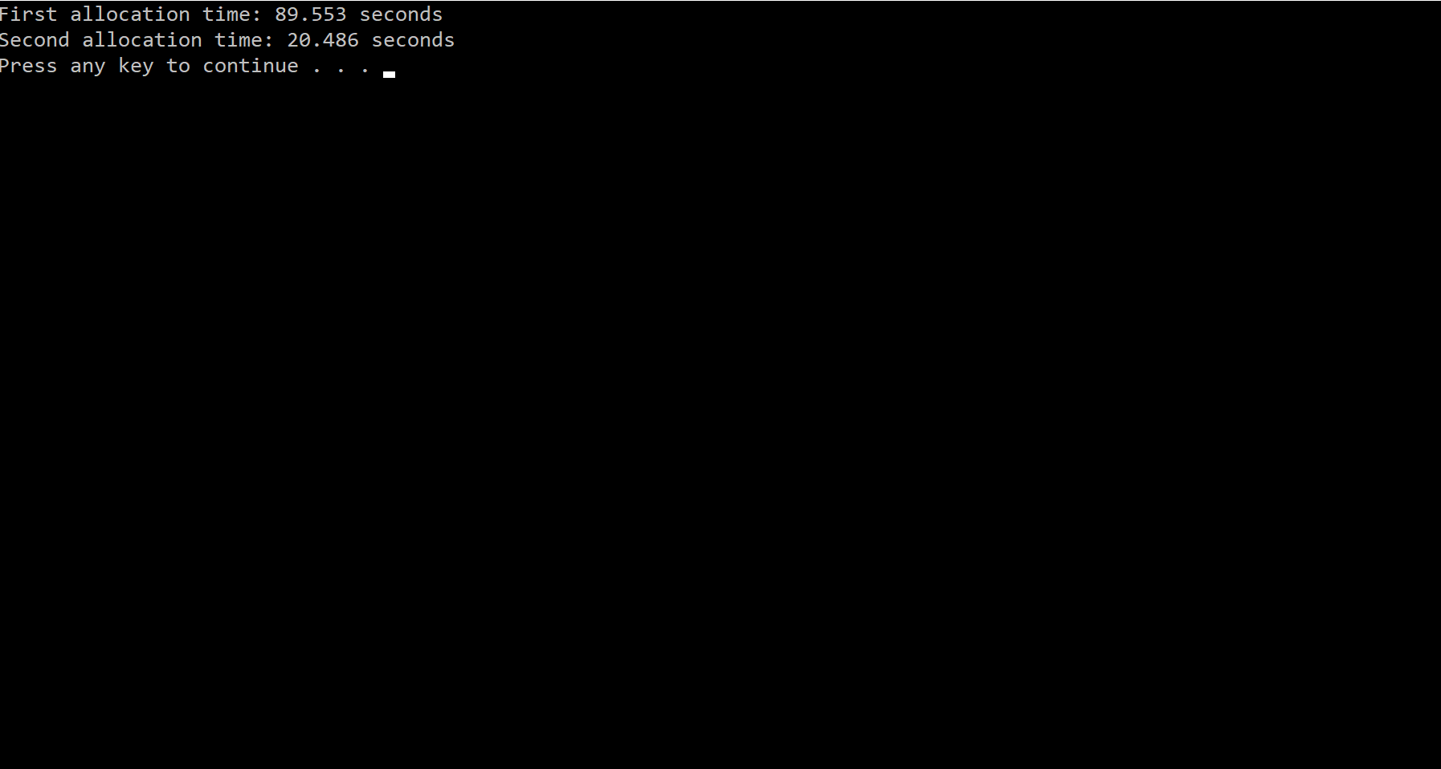

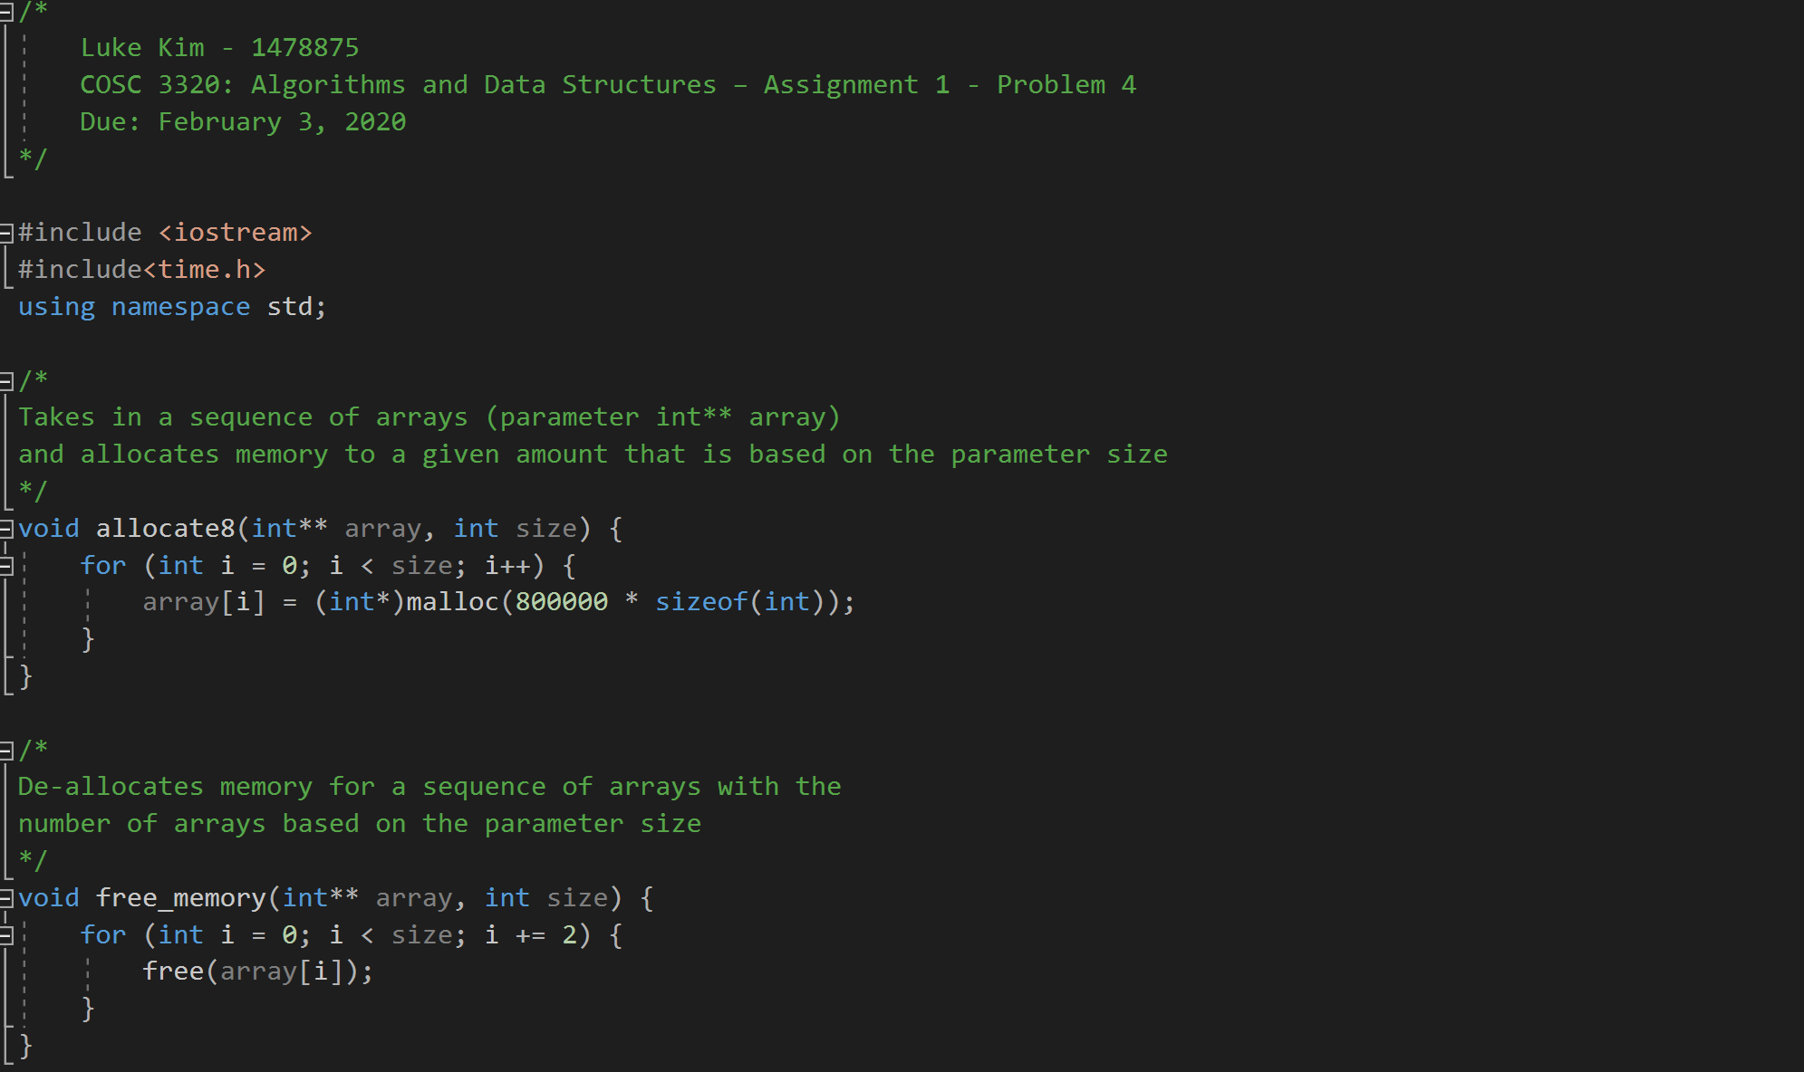

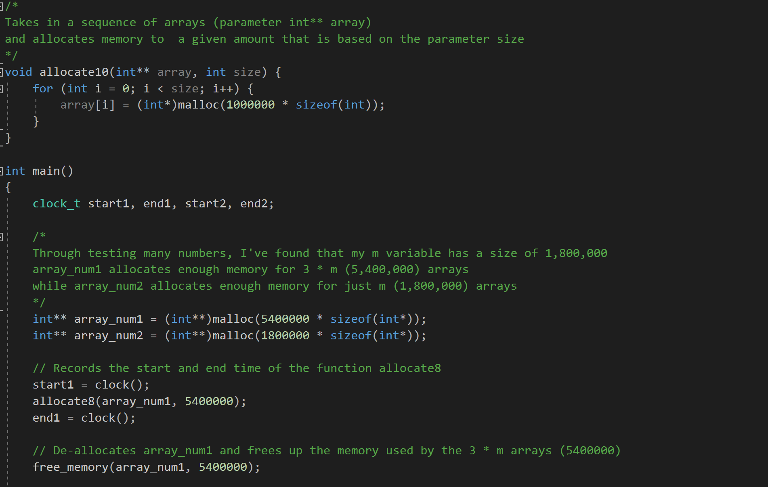

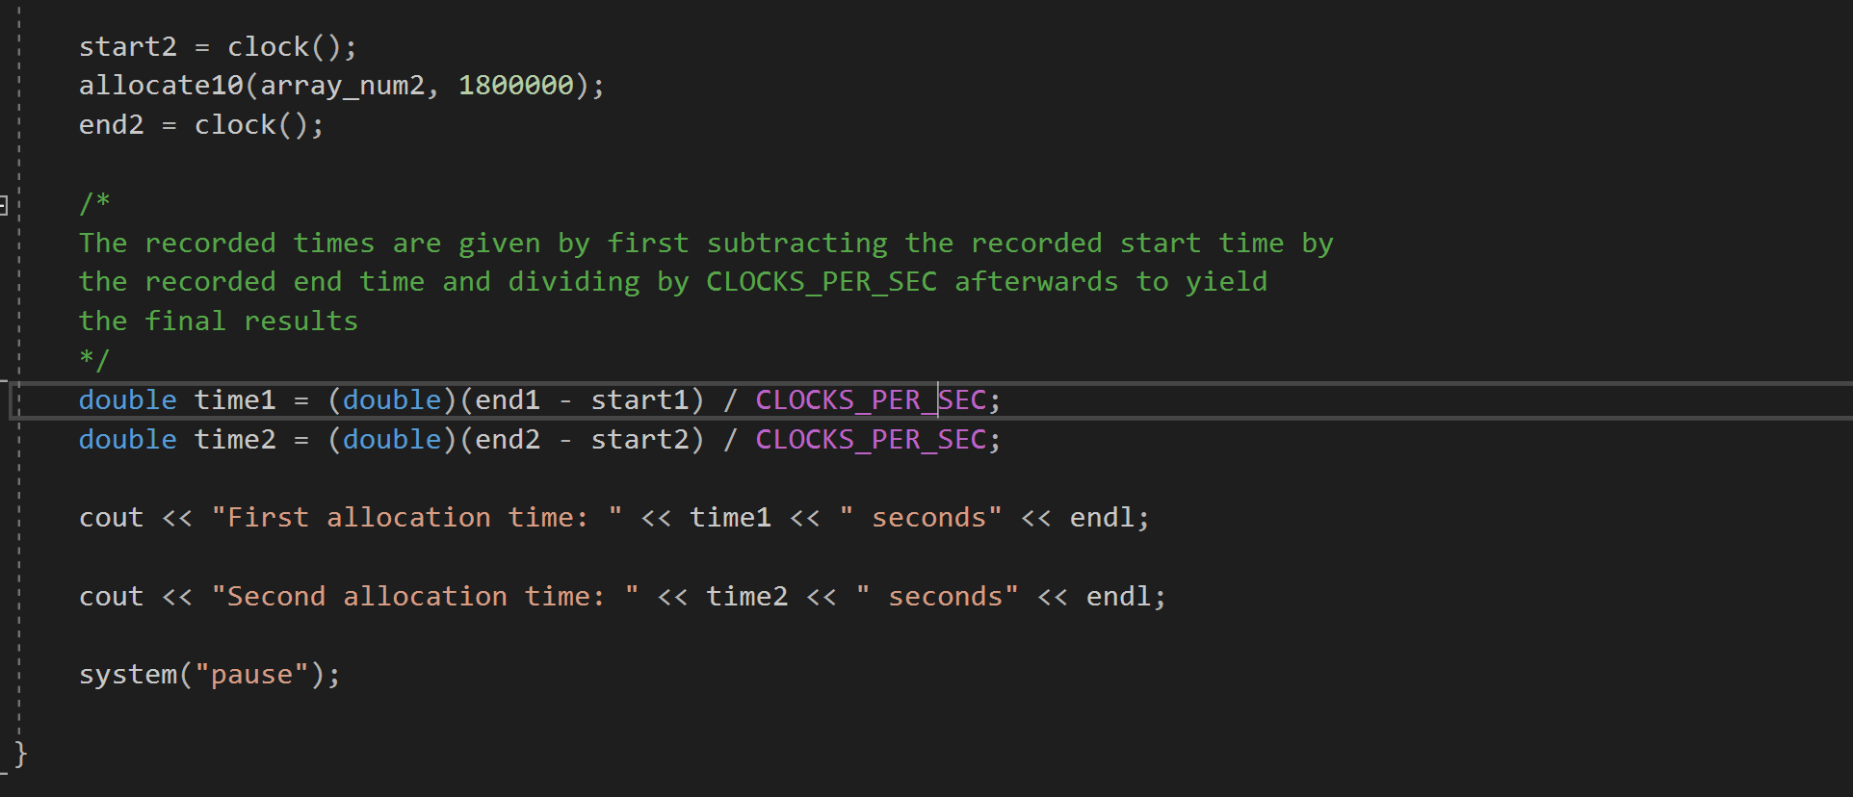

**Hypothesis:**

The first allocation will take longer due to having a larger sequence of arrays to allocate memory for. The first allocation contains 3*m (3 * 1,800,000 or 5,400,000) arrays with 800,000 elements each. This is equivalent to generating enough memory for 4.3 trillion elements.

**Hypothesis validation:**

As expected, the ratio of time taken between the first allocation and the second is about 4.5:1. This is very close to the ratio of number of elements, as the number of elements in the second allocation is 1.8 trillion elements. My hypothesis is validated as the larger number of arrays to allocate memory for causes the program to take a much longer time to finish compiling.

**Problem 5:**

**C++** **Timings and Code:**

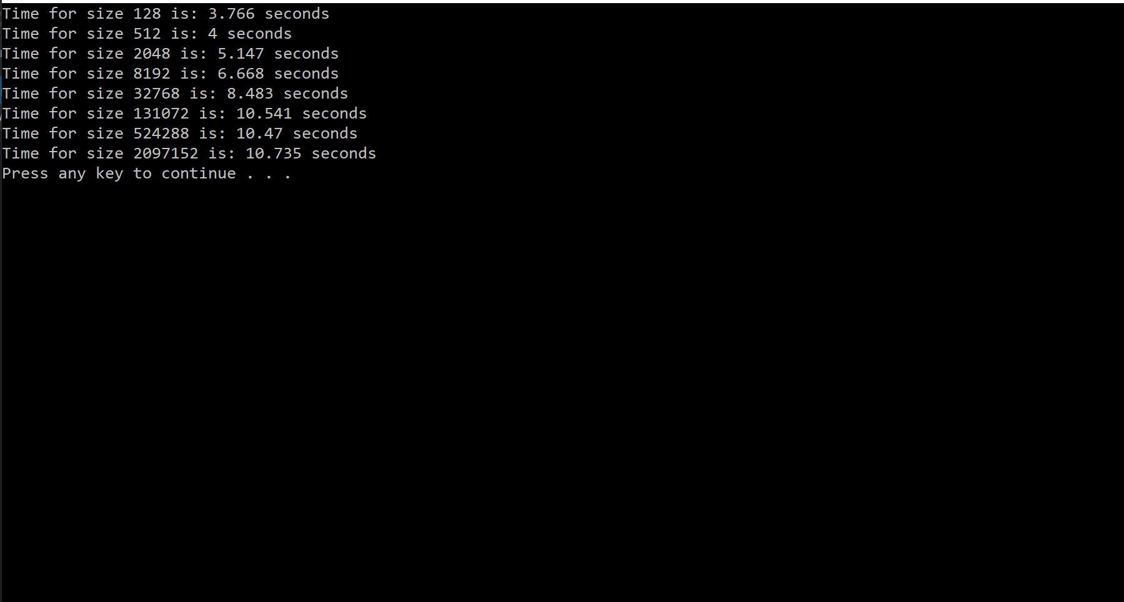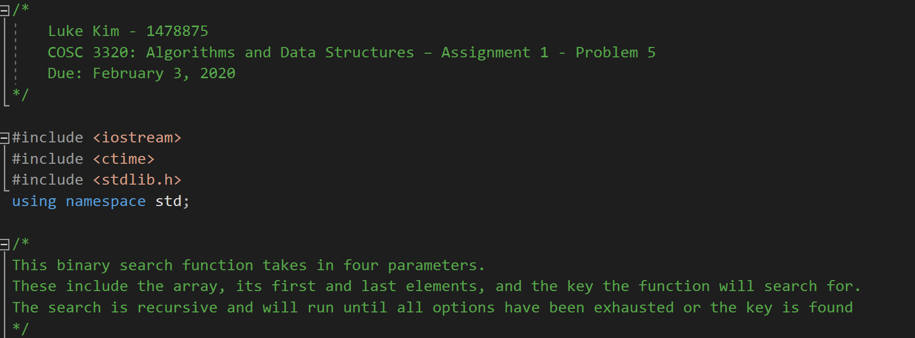

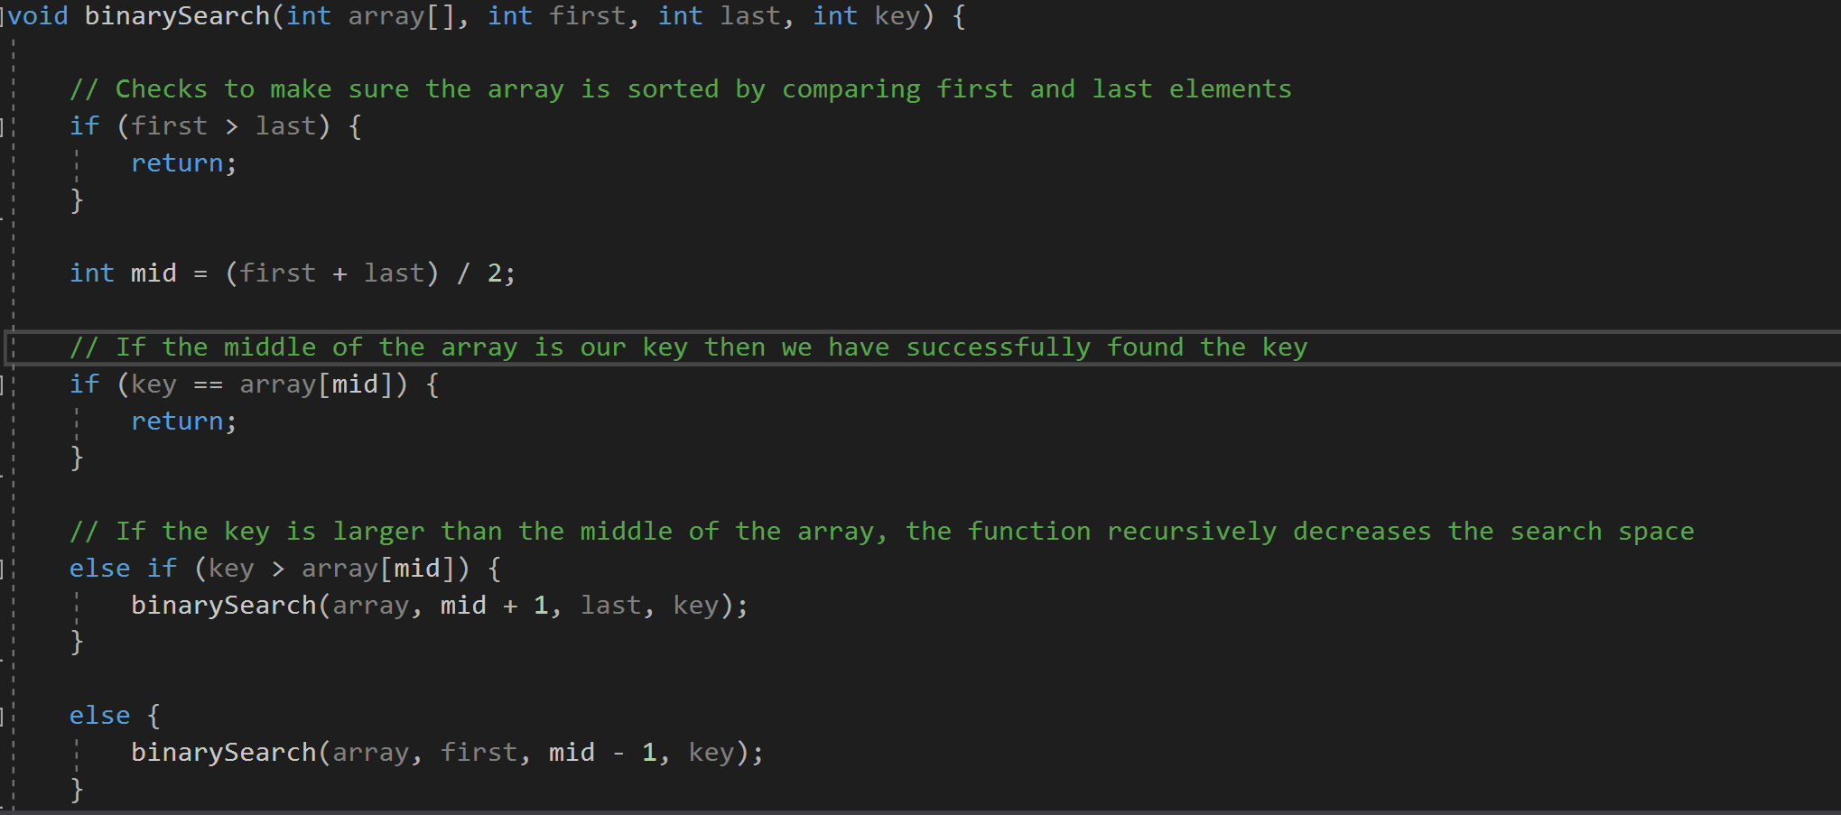

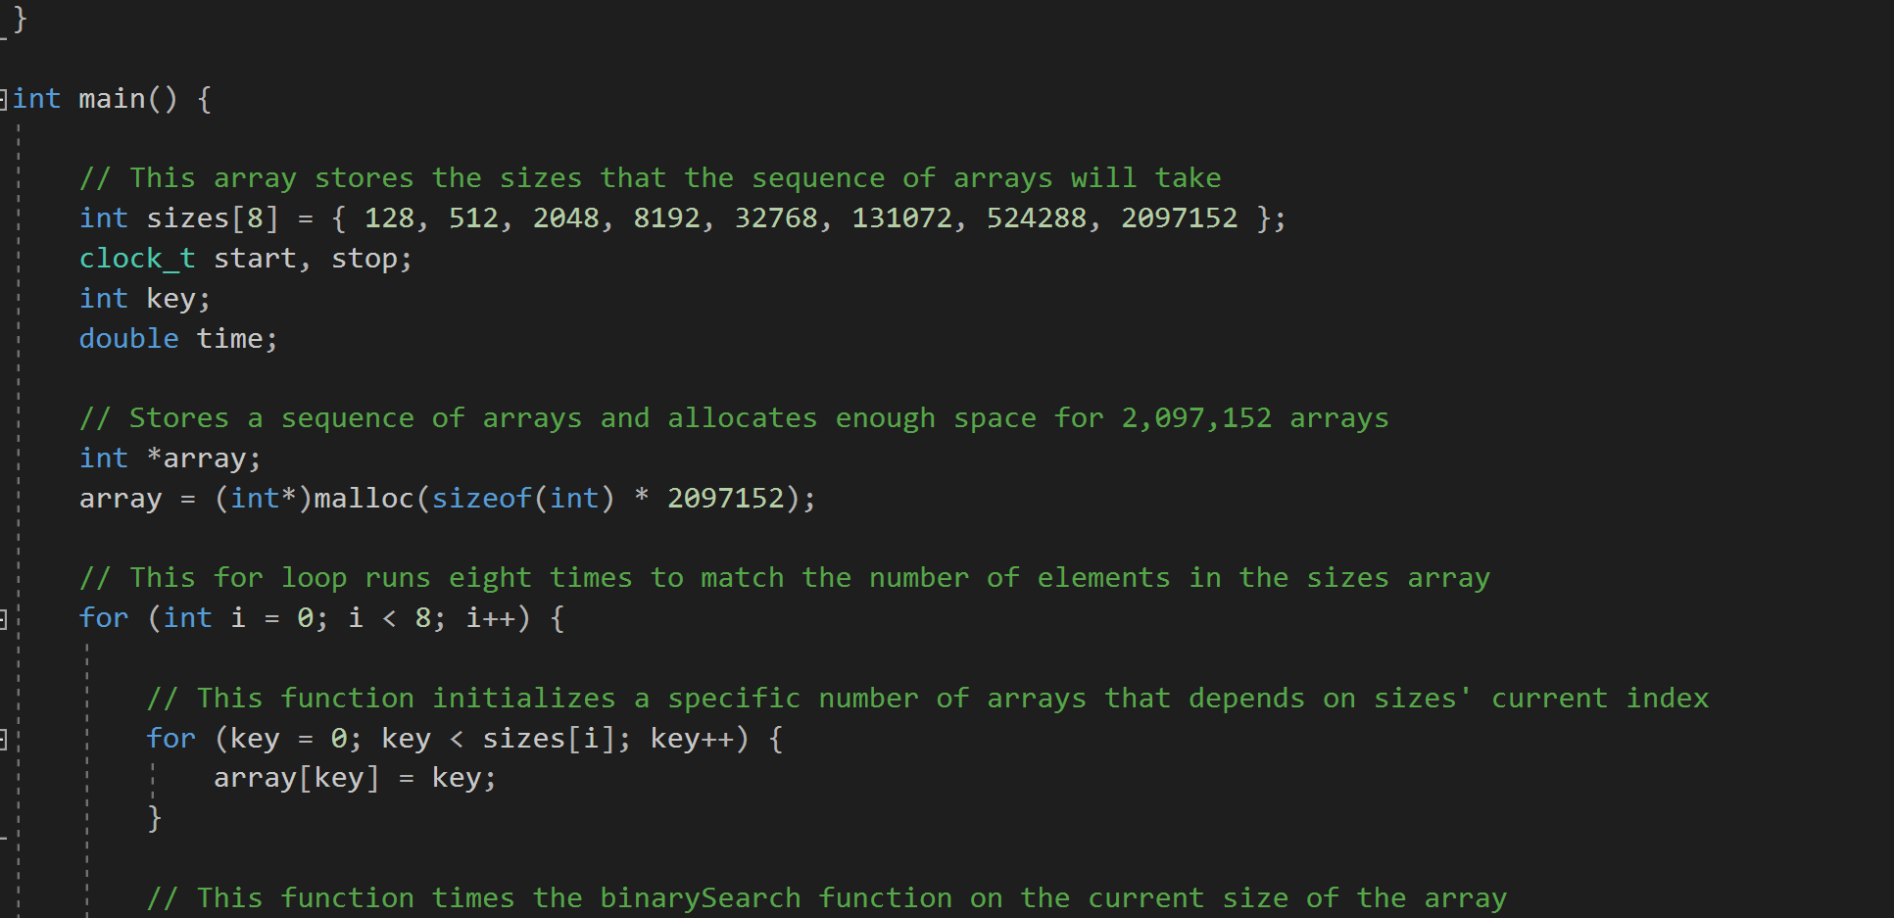

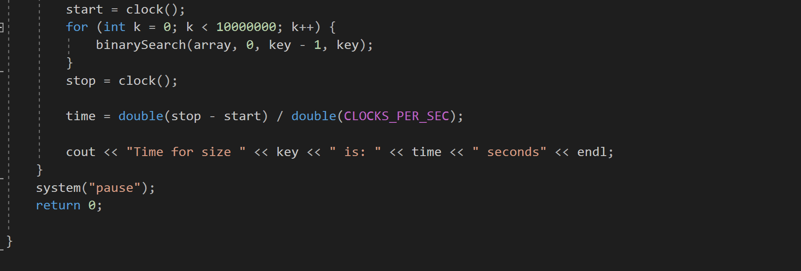

**Java Timings and Code:**

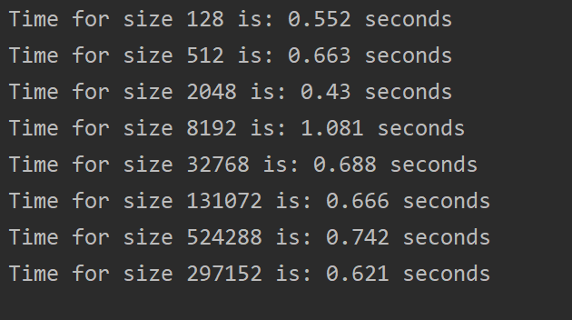

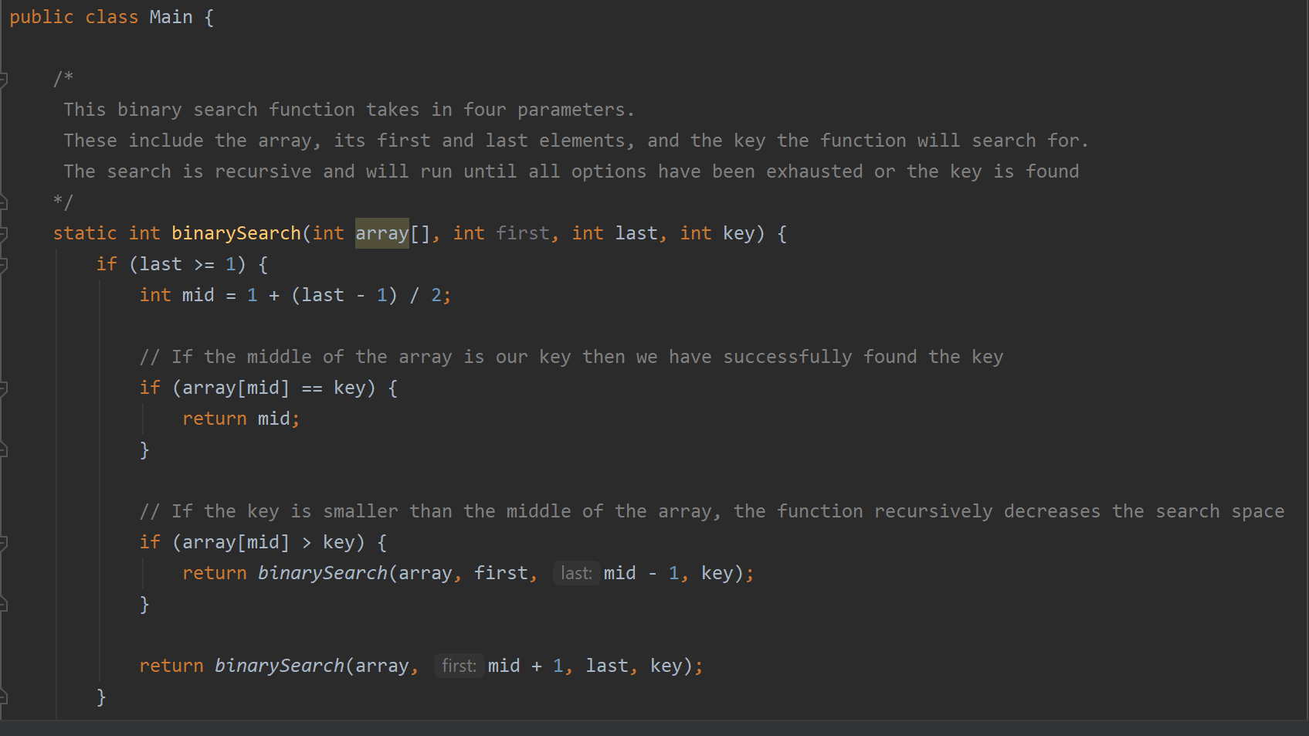

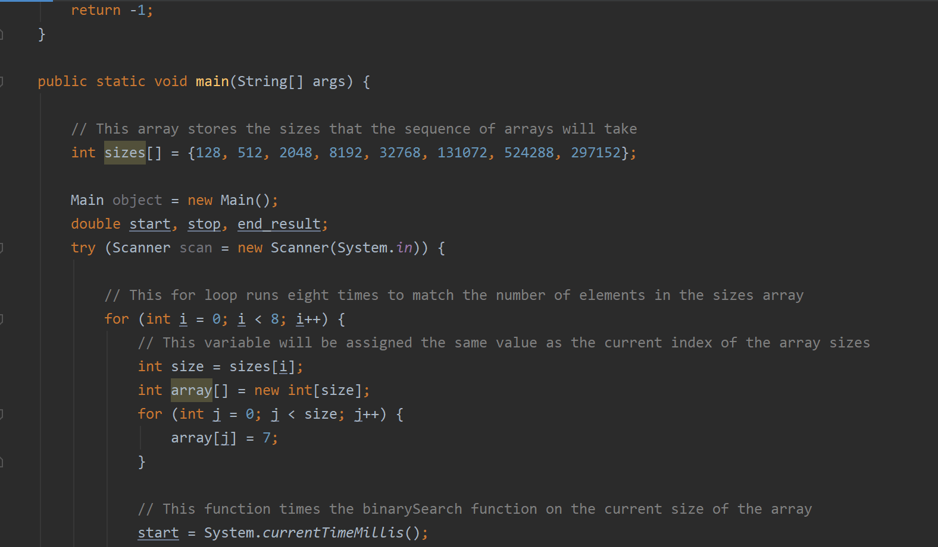

**Python Timings and Code:**

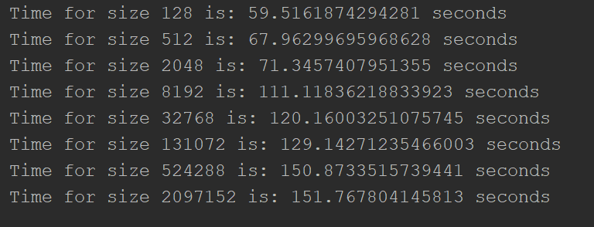

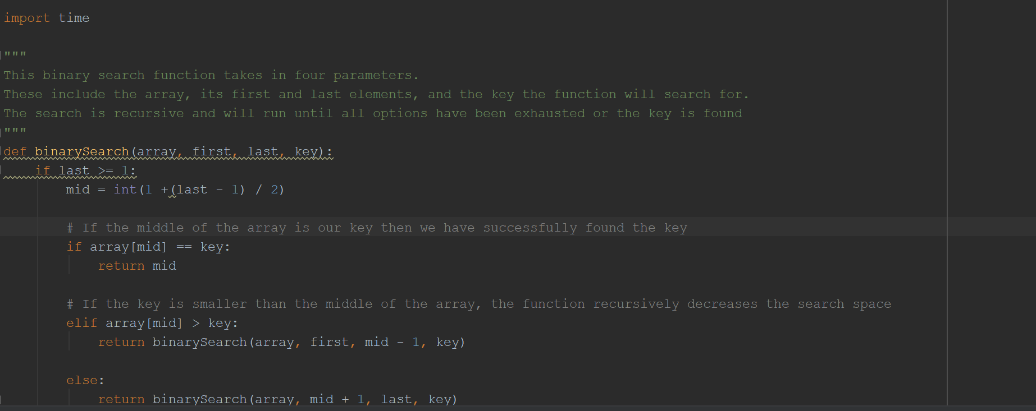

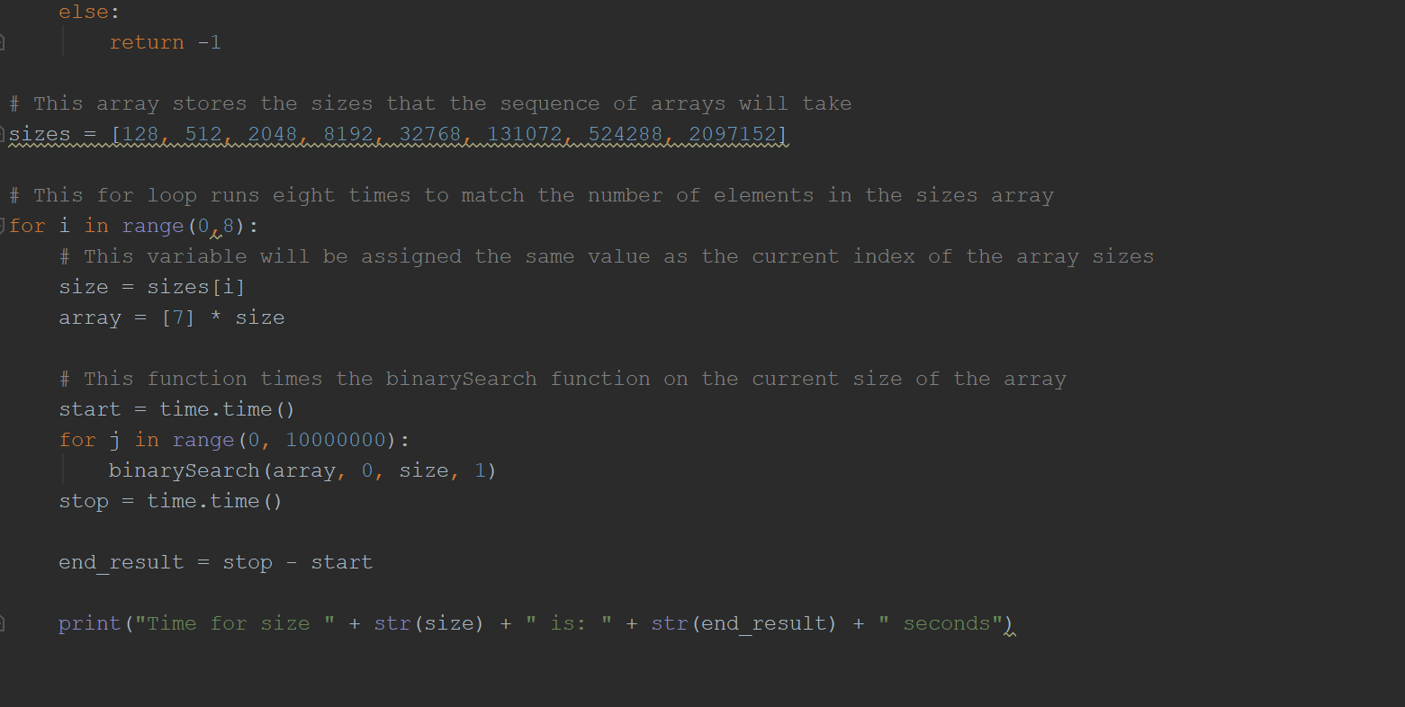

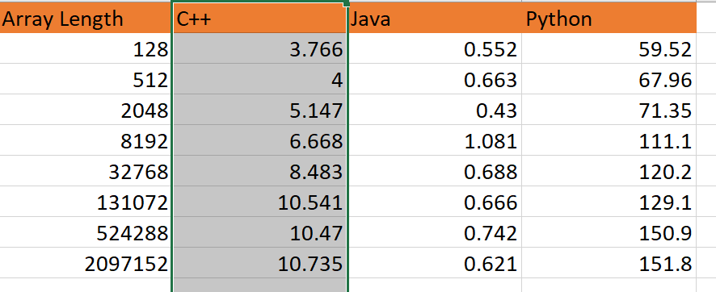

The above numbers show the runtimes for each programming language based on which array length was used. All three languages used the exact same syntax to compile, and the system environment when compiling was controlled and equivalent throughout all the runs for each language. The largest disparity is between Java and Python. Python runs significantly slower than Java due to having dynamic typing for its variables as well as taking the longest to access the arrays. C++ is moderately fast in comparison to Java and Python due to using more memory than Python, which leads to less time being spent on searches. There are several factors that lead to Java’s runtime. The static methods that Java uses have a quick access time due to their location never changing. Java also uses more memory than both Python and C++, which helps lead to a quicker runtime.

Problem 5 Sources:

<https://www.geeksforgeeks.org/static-methods-vs-instance-methods-java/>

<https://www.geeksforgeeks.org/binary-search/>

<https://stackoverflow.com/questions/7370801/measure-time-elapsed-in-python>

<https://www.tutorialspoint.com/compute-elapsed-time-in-seconds-in-java>

<https://www.python.org/doc/essays/comparisons/>